Karnataka Valuation & E-Registration (KAVERI - 2.0)
Government of Karnataka

Functional Requirement Specifications

For KAVERI 2.0
Department of Stamps & Registration
Government of Karnataka
Version 1.7
___________________
Firm Registration Module

Prepared by
Centre for Smart Governance (CSG)
2nd Floor, TTMC Yeshwanthapura, BMTC Bus station
Bangalore – 560022

Acronyms
CSG | Centre for Smart Governance
DEO | Data Entry Operator
DR | District Registrar
DRO | District Registrar Office
DFDA | District First Division Assistant
DSDA | District Second Division Assistant
SRO | Sub Registrar Office

Revision History
Date | Version | Prepared by | Approved by | Reason for Changes
26.03.2023 | 1.0 | Basanti Prahlad | Department
16.03.2024 | 1.1 | Arugolli Subhash | Saurabh Bhattacharya
05.04.2024 | 1.2 | Vani P M
29.06-2024 | 1.3 | Pavan Kumar |  | Addition of amendments.
10-07-2024 | 1.4 | Pavan Kumar |  | Updating the FRS based on answers to the clarificatory questions.
01-08-2024 | 1.5 | Pavan Kumar |  | Updating the FRS-based feedback received.
23-08-2024 | 1.6 | Pavan Kumar |  | Addition of offline flow and integration with Kaveri 1 data.
20-07-2026 | 1.7 | Kavyashree D |  | K1 Data correction, capture deceased partner details and provision to upload the supporting document

Contents
Acronyms 2
Revision History 2
1. Introduction 5
2. Document scope 5
3. Overview 6
4. Overall Functional Flow 7
5. Functional Description 8
5.1 Registration of Firm 8
5.2 Amendment of Registered Firm 22
5.3 Reconstitution of firm 38
5.4 Dissolution of firm 48
5.5 Protest Entry 55
5.6 Index Search 60
5.7 Certified copy - CC 64
Integration with other systems/modules 68
External integration 68
Assumptions and Dependencies 68
Assumptions: 68
Dependencies: 68
Limitations 68
Annexure – 1 – List of modules of Kaveri 2.0 68
Annexure 2: Objectionable Names or Emblems 70
Annexure 3: Checklist under DRO Login 71
Annexure 4: Input and Output Forms 72
Annexure 5: Clarificatory questions and Answer from Department, 73
Feedback provided by Department, dated: 19-07-2024 73
New Firm Registration: 73
Amendments: 73
Reconstitution: 74
Dissolutions 74
Certified copy: 74
Index Search: 74
Protest Entry: 75
SAKALA Integration: 75
Feedback provided by the Department, dated: 26-07-2024 76
Feedback provided by the Department, dated 21-08-2024 77
Annexure 6: Input Forms 78
Application of new firm Registration Form- I 78
Amendment -I: Form II 79
Amendment -II: Form III 80
Amendment -III: Form IV 81
Amendment -IV: Form VI 81
Re-Constitution: Form V 82
Dissolution: Form V 82
Annexure 7: Output forms 83
Form B Index to the Register of Firms 83
Form D Memorandum Acknowledging Receipts of Documents 83
Form A Register of Firms 84
Form C Acknowledgement of Registration of Firms 85
Form E Receipt of Fees 86
Annexure 8: Services to be provided for firms registered in Kaveri 1 86

Introduction

The Department of Stamps and Registration (hereafter referred to as “department”) is the custodian of registered public records such as Registration of Marriages and Firms, Documents pertaining to transactions, namely sale, transfer, or gift of immovable properties, Mortgage, Power of Attorneys, wills and many more. The department's prime responsibility is to maintain and preserve these critical public records. The records or the information associated with registered records are to be made available to the public when requested through defined procedures. The department is also responsible for collecting stamp duty on behalf of the Government for specified transactions. The services are provided through 256 Sub-Registrar Offices (SROs) under the supervision of 34 District Registrar Offices spread across the state.
The department has computerised the delivery of these services through the development of KAVERI software. KAVERI Online service is a web-based application of the department which provides an interface to the citizens required for documents, marriage, and firm registration. It enables citizens to know the details of stamp duty, property guidelines value, data entry for document registration and marriage registration, etc. The list of modules of KAVERI 2.0 is available in Annexure 1.

Document scope
This document is a Functional Requirement Specification (FRS) describing the functional features of the Firm Registration, Amendment, Reconstitution, and Dissolution Module in document registration via Kaveri 2.0. The draft document is prepared by the Centre for Smart Governance (CSG) and has to be approved by the department. The intended audience of the document is the departmental approving authority and the development team of CSG.
The document was prepared through document analysis and departmental consultation. The high-level requirements were shared by the department.

Overview
Partnership is the relation between persons who have agreed to share the profits of a business carried on by all or any of them acting for all. Persons who have entered into partnership with one another are called individual Partners and collectively a Firm, and the name under which their business is carried on is called the Firm Name.
The module on firm registration seeks to enable the online registration of firms within Kaveri 2.0. The following functions are required as part of the firm module.
- New Firm Registration: The Constitution or declaration of terms and conditions of a firm signed by two or more individuals to carry out a business or an institution.
- Re-Constitution of the Firm: Change in the constitution of the firm – Incoming/ Outgoing Partner.
- Amendment of the Firm: Any change to the Firm such as name or location of the principal place of business, change in the place of business, alteration in the name or permanent address of the partners, notice of election by a person admitted to the benefit of partnership on attaining majority.
- Dissolution of the Firm: The dissolution of a partnership between all the partners of a firm is called the “dissolution of the firm”.
- Protest Entry: Any partner or other person interested makes a protest in writing to the Registrar disputing any entry made in the Register of Firms
Apart from these functionalities, the inspection of the indexes to the register of firms and of original documents and also the access to certified copies are to be provided.

4. Overall Functional Flow
The above-mentioned functionalities take place in the office of the District Registrar under the Department of Stamps and Registrations, Government of Karnataka under the Indian Partnership Act 1932. These functions are sought to be made available online through the Firm Registration module under Kaveri 2.0 and are elaborated in this document.
However, the functionalities of firm registration, reconstitution, and dissolution are also related to The Karnataka Stamp Act, 1957, for stamp duty collection. Firm registration, for instance, involves the registration of a partnership deed in the office of the sub-registrar, which is part of the document registration module of Kaveri 2.0 and has already been implemented. Thus, registration of a new firm involves two steps (Figure 1)
- Document registration of a partnership deed in the Office of the Sub-Registrar
- Registration of the new firm in the Office of the District Registrar.

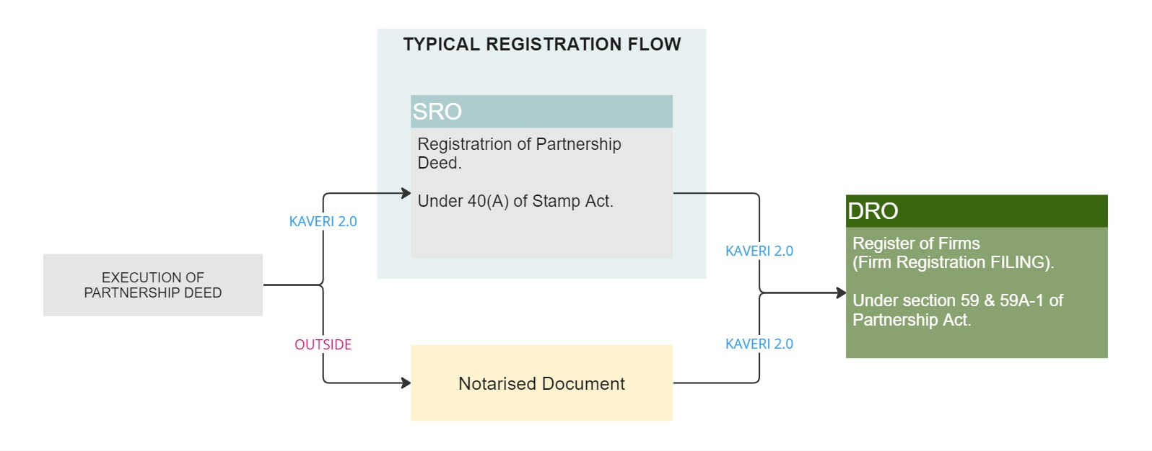
Figure 1: Typical flow of new firm registration
Similarly, the reconstitution and dissolution of the firm requires the concerned documents to be registered and due payment of stamp duty in the office of the sub-registrar upon which they are filed in the office of the district registrar.

5. Functional Description

5.1 Registration of Firm
The registration of firms consists of two distinct steps (Table 1). Citizens can register the partnership deed for the constitution of the firm in Kaveri 2.0. The registration process follows the typical document registration flow at SRO. After registering the partnership deed, citizens can file their firm at Kaveri 2.0 by submitting the application.
Sl. No | Action required | Actors | Statutory provisions
1 | Document Registration of Partnership Deed  Under 40(A) of Stamp Act | Partner or Agent,  SRO | The Karnataka Registration Act, 1908  Karnataka Stamp Act, 1957
2 | Registration of firm  Under Sections 59&59A-1 of the Partnership Act | Partner or Agent,  DRO | The Indian Partnership Act, 1932
Table 1: Steps for registration of a firm

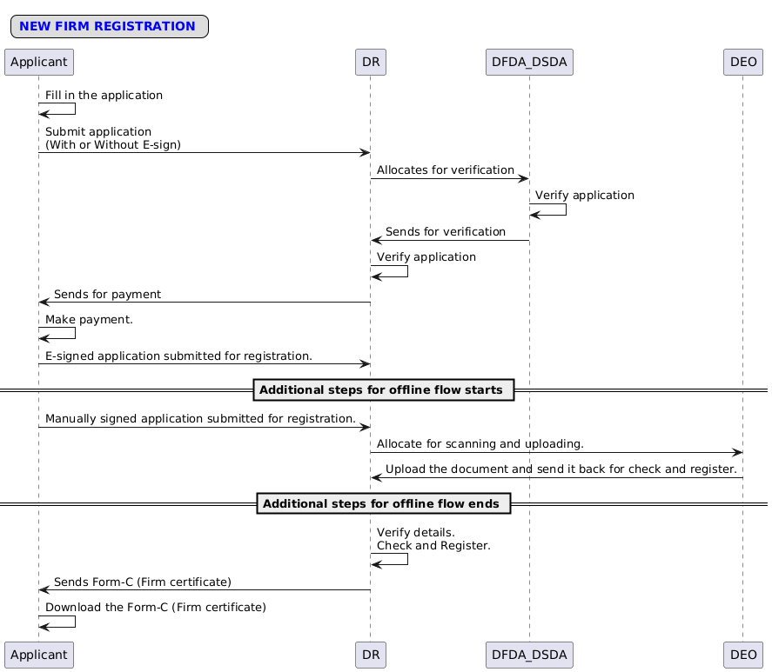
Figure 2: New Firm Registration process.

Process Flow:
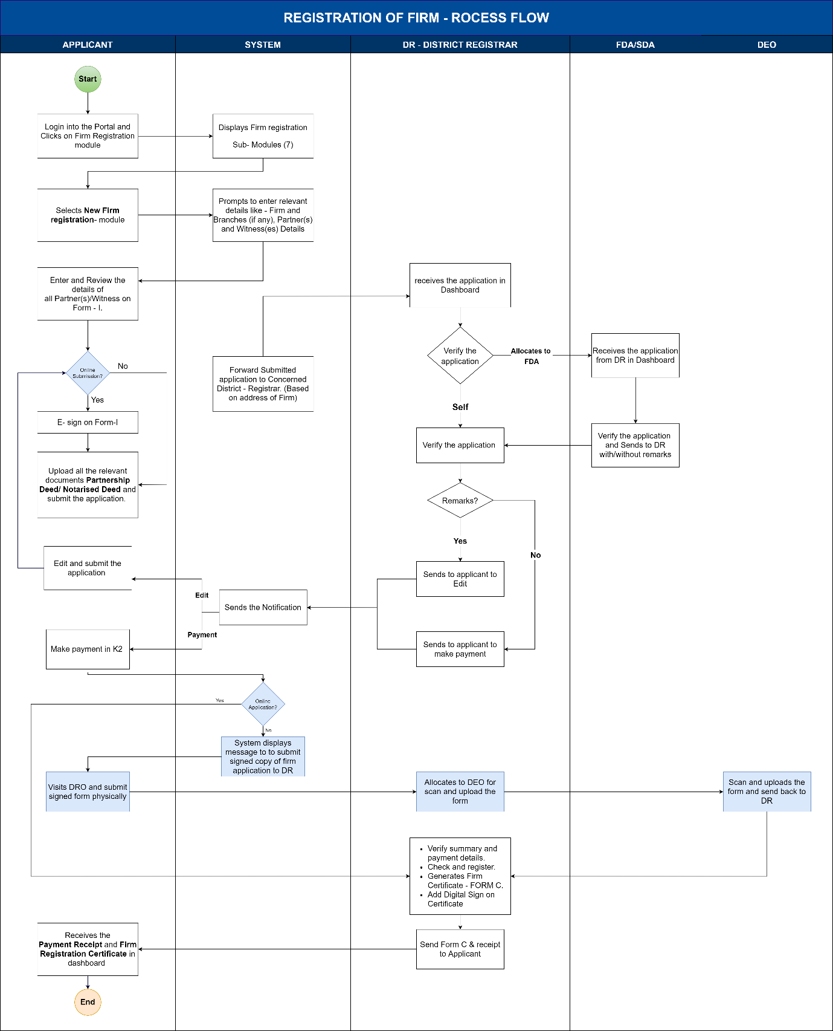
Figure 3: Process flow for new firm registration

Functional Requirement Specifications
Stakeholder/ Interface | Role/ Responsibilities
Applicant (Partner or Agent) | - File the application for Registration of firm  - Online Data Entry  - Submits the application form -1 (With or Without E-sign)  - Upload Relevant Documents  - Payment of fees  - Collect Fee Receipt  - Collect Digitally Signed Firm Certificate
DFDA/DSDA | - Verification of allotted application  - Verification of the documents Submitted  - Add Remarks (If Any)  - Send back to DR after verification.
DR | - Verification of the application  - Allocate applications for verification of summary to DFDA/DSDA  - Verification of the documents Submitted  - Re-verify the DFDA/DSDA verified applications.  - Add Remarks (If Any)  - Send back to the applicant for Payment  - Approval of Registration in the System  - Issuance of Certificate of Registration with digital sign.
System | - Validations including Firm name, Age of partners, agents, guardians, witness, date of joining of a partner, and date of appointment of agent  - Select the DRO of the jurisdiction where the principal place of the firm is located  - Calculation of Fee and penalty.  - Displays a message for application without E-sign.  - Routes the application to DR based on the applicant’s signature method.  - Generate and print Acknowledgment and Fee Receipt  - Update the Register of Firms and its Index  - Generation of Firm Certificate  - Accounting entry for each transaction in A-Register  - Generation of MIS Reports
Process Triggers | - Receiving application at DR Office
Process Description | Bird view of New firm registrations  New firm registration consists of 8 screens for applicants to submit the application, which captures details as shown below table:  New firm registration consists of 7 screens for DR to generate the certificate,  New firm registration consists of 1 screen for DFDA/DSDA to verify the application and send it back to DR:  The detailed flow is explained below in the FRS table.  New firm registration consists of one screen for DEO to Upload the Signed application form-1:  The detailed flow is explained below in the FRS table.  Process description  Application Filing (Applicant):  - Application to be filed in the Kaveri 2.0 Portal  - Select the Service required. The services provided are  - Registration of New Firm  - Amendment of firm  - Re-Constitution of Firm  - Dissolution of Firm  - Protest Entry  - Index Search  - Certified Copies  - For New Firm Registration, the applicant must enter the Following Details:  - Firm Details  - Firm Other Place of Business details (if any)  - Partner(s) Details  - Agent(s) Details  - Witness(es) Details  Firm Details  - Name of the Firm (mandatory) alphanumeric field, up to 250 characters. All special characters are to be allowed (no validation for special characters).  System searches in the index of register of firms for registered firms with the name and address.  - If the firm’s name contains objectionable names as per Emblem Act it should not proceed, the system should prompt an error message and ask the applicant to change the name.  - If the firm’s is the same as the existing firm’s name in the index of firms, then the system shall ask for a change in the name of the Firm.  - Phone Number / Mobile Number (mandatory) numeric field of 12 characters.  - Nature of Business (mandatory) text field, up to 250 characters.  - Principal place of business –  House No./Building Name (250 characters, all the special characters are allowed), Street Address, State, District, Taluka, Hobli/Ward, Village/City, Pin code (all are mandatory fields), and should be in Karnataka only. (District, Taluka masters of registration department to be used)  - Date of constitution of the firm (mandatory) calendar. Should not be allowed to enter the future dates.  - Duration of Firm: At will/ Particular Partnership (mandatory) (Radio Buttons are to be provided to select by the applicant, and a calendar is to be provided in case of selection of Particular Partnership. Validation is to be given based on the date of the constitution. The date entered by the applicant should not be before the date of the constitution.  - Other Place of Business(es) (mandatory) Radio Buttons, Yes and No, are to be provided to select other places of business, and if the selection is yes, then the address is to be collected. Else, proceed to the next screen.  If the selection is yes, then, Other Place of Business(es) address: House No./Building Name (250 characters, all the special characters are allowed), Street Address, State, District, Taluka, Hobli/Ward, Village/City, Pin code (all are mandatory fields)  Other places of business (es) can be found across India and are not restricted to Karnataka.  - Upon entering the Firm Details, the System must Select the DRO of the Jurisdiction where the Principal place of the firm is located.  Partner details  - Name of the Partner  - Salutation (dropdown) (mandatory field)  (Ex: Sri., Smt., M/S, Mr., Mrs., Ms., Kumari., Kumara)  - First Name, Middle Name, Last Name:  (Only first Name is a mandatory field; middle and last name are optional) Fifty characters are allowed.  - Relationship (dropdown)  (Daughter of, Son of, Care of) (mandatory field)  - Relative Name (mandatory field) (manually enter data) 250 characters. No special characters are allowed.  - Date of Birth (calendar) (Mandatory field)  - Age (in years) should be auto-calculated once DOB is entered.  - Even a minor can be a partner. If the age is <18, then guardian details are to be collected mandatorily based on the DOB entered for the partner.  Below details should be captured for the guardian,  - Name of the Minor guardian  - Salutation (dropdown)  (Ex: Sri., Smt., M/S, Mr., Mrs., Ms., Kumari., Kumara) (mandatory field)  - First Name, Middle Name, Last Name  (Only First Name is a mandatory field; Middle and Last Name are optional) Fifty characters allowed.  - Relationship: The only option is for Guardian to be selected from the dropdown.  - Date of Birth (calendar) (Mandatory field)  - Age (in years) should be auto-calculated once DOB is entered, and age should be >=18.  - Address –  House No./Building Name (250 characters, all the special characters are allowed), Street Address, State, District Taluka, Hobli/Ward, Village/City, Pin code (all are mandatory fields)  Note: Address can be anywhere across the country  - Partner Gender (mandatory field) Radio Buttons  Male, Female, Transgender  - Partner Occupation (optional field) text field with 50 characters.  - Mobile Number (mandatory) numeric field of 12 characters.  - Email ID (optional field) alphanumeric field with special characters with email ID format validation.  - Date of Joining the firm (fetched field) This field should be fetched from the date of the firm constitution.  - Address – (Current and Permanent)  House No./Building Name (250 characters, all the special characters are allowed), Street Address, State, District Taluka, Hobli/Ward, Village/City, Pin code (all are mandatory fields)  If both current and permanent addresses are the same, a check box should be provided to copy the address.  (Note: Address can be anywhere across the country.)  - Is the partner represented by the agent? (Mandatory field) Yes or No radio buttons should be provided. If Yes is selected, then the applicant should key in agent details as below,  Agent Details:  - Name of the agent  - Salutation (dropdown) (mandatory field)  (Ex: Sri., Smt., M/S, Mr., Mrs., Ms., Kumari., Kumara)  - First Name, Middle Name, Last Name (only First Name is mandatory field, Middle and Last Name are optional) 50 characters allowed.  - Relationship (dropdown) (Daughter of, Son of, Care of) (mandatory field)  - Relative Name (manually enter data) 250 characters. No special characters are allowed (mandatory field)  - Date of Birth (calendar) (Mandatory field)  - Age (in years) should be auto-calculated once DOB is entered; age should be >=18.  - Gender (mandatory field) Radio Buttons – Male, Female, Transgender  - Occupation (optional field): 50 characters are allowed, and no special characters are allowed.  - Mobile Number (mandatory) numeric field of 12 characters.  - Email ID (optional field) alphanumeric field with special characters with email ID format validation.  - Address – Only permanent address to be collected  House No./Building Name (250 characters, all the special characters are allowed), Street Address, State, District Taluka, Hobli/Ward, Village/City, Pin code (all are mandatory fields)  Note: Address can be anywhere across the country  The applicant has to upload the GPA / Supporting Document for the agent. PDF format max file size 5MB.  - The same details should be auto-fetched in the presenter’s tab when the agent’s name is selected as the Presenter.  - The minimum number of partners is two, and the maximum is Fifty. (Provision to be made to enter the details of the maximum number of partners)  - A Firm cannot be a partner for another Firm, whereas a Company can become a Partner of a Firm.  Witness details  The witness must be either a Gazette Officer, Advocate, Attorney, Vakil, Honorary Pleader, Chartered Accountant, or Registered State Auditor. Their profession must be captured.  - Choose partners to identify (mandatory) from the dropdown which contains the name of partners.  - Name of the witness  - Salutation (mandatory field) (Ex: Sri., Smt., M/S, Mr., Mrs., Ms., Kumari., Kumara).  - First Name (mandatory field), Middle Name, Last Name (optional)  - Date of Birth (calendar) (mandatory field)  - Age (in years) should be auto-calculated once DOB is entered; witness age should be >=18 years)  - Gender (mandatory field) Radio Button – Male, Female and Transgender  - Profession (dropdown) (mandatory field)  - Gazetted officer  - Advocates  - Magistrate  - Notary public  - attorney of the High Court  - Pleader  - Charged Accountants  - Restricted State Auditor  - Sales Tax Act Practitioner  - Income Tax Act Practitioner  - Mobile Number (mandatory field) numeric field of 12 characters with allowed special characters.  - Email ID (optional field) alphanumeric field with special characters with email ID format validation.  - Address – Only permanent address to be captured  House No./Building Name (250 characters, all the special characters are allowed), Street Address, State, District Taluka, Hobli/Ward, Village/City, Pin code (all are mandatory fields)  Note:  The address can be anywhere across the country  A witness can identify any number of partners, but a partner can be identified by exactly one witness.  Presenter Details  - Choose the presenter: (mandatory) dropdown (agent or partner). Based on the selection of presenter, the details will be auto-fetched (which is already captured under partners details).  Note:  If a partner is represented by an agent then the agent’s name should appear instead of the partner’s name in the dropdown list.  - Once the applicant selects the presenter and clicks on the Continue button, the system should display the summary.  - Applicant reviews the data entered, and he is provided with three options:  - Use the edit button at this stage to make changes (if necessary).  - Sign online (which displays Form I upon clicking)  - E-sign to complete the signatures of all the partners digitally.  - Close to come back to the summary page.  - Sign offline: which displays Form I upon clicking with a message “This Application form should be duly signed and submitted to District Registrar Office upon successful verification” to take the print and manually sign and submit the application to DR office.  - Upon completing the summary verification, the applicant should be redirected to the application to upload relevant documents (in PDF Format allowed up to 5MB).  - Partnership Deed (mandatory) dropdown with options Notarized deed and Registered.  - Document number: (mandatory) alphanumeric field up to 30 characters (all special characters are allowed).  - Address Proof for Firm principal place of business (mandatory)  if it is owned by the firm, then a Tax Paid Receipt or Sale deed copy can be accepted as Address Proof, and if it is rented, a duly stamped Rental Agreement copy is to be provided.  - Address Proof for Firm Other place of business (If any) (mandatory)  For Other Place of Business: if it is owned by the firm, then, a Tax Paid Receipt or Sale deed copy can be accepted as Address Proof and if it is rented, a duly stamped Rental Agreement copy is to be provided.  (Address proof should be collected based on the number of other places of business entered during firm details.)  - ID Proof of the Partner(s), Agent(s), Witness(es), Presenter(mandatory)  (Driving License / PAN / Voter ID (EPIC Card) / Aadhar Card / Passport)  - Proof of Address for Partner(s), Agent(s), Witness(es), Presenter(mandatory)  (Sale Deed/Aadhar Card/Driving License/Passport/EPIC Card (Voter ID)/Duly stamped Rental Agreement (in case of rented house))  - Additional supporting document (if any) (optional)  - Supporting Document 1  - Supporting Document 2  Note: A note must be added below the partnership deed stating the following:  “If the document is not duly stamped, the original document has to be produced before the District Registrar for adjudication purpose”.  - Applicant must view the fee table and click on Submit.  - Once the application is submitted, the system will send the SMS to the applicant in the below format  “Your FIRM Application (FORM I /II/III/IV/V/ VI) is submitted successfully to DRO (Office Name) with (Application Number xxx) From the Department of Stamps and Registration.”.  From: Department of Stamps and Registration.  - Upon the acknowledgement of the application by DR, the applicant must make the fee payment online.  - After the DR checks and registers, the applicant can download the Form E: Fee Receipt as well as the Form C: Firm Registration Certificate.  Fee Calculation (System)  - The System shall calculate and display the fee for processing the application  - Registration Fee = Rs.100 (fixed)  - Application Fee = Rs.3 (fixed)  - Total Payable Amount (in Rs.) = 100+3  - Applicant shall view the fee details and apply.  Application Verification (DR):  - The DR views the firm application by clicking on the ‘View’ button and can allocate to DFDA/DSDA for verification or click on the ‘Verify’ button for self-verification of the received application.  Allocation to DFDA/DSDA:  - DR selects the name of DFDAs/DSDAs from the dropdown and allocates the firm application to DFDA/DSDA by clicking on the ‘Allocate’ button for verification.  Verification by DFDA/DSDA:  - The DFDA/DSDA shall start the verification process by selecting the ‘Start Verification’ button.  - The DFDA/DSDA Application verification screen is split into two sides:  - LHS (Left-hand side of the page) – the Summary sheet containing all the details that the Applicant has entered (firm details, partner details, witness details), a section to add his remarks, and a button to send it back to the DR  - RHS (Right-hand side of the page) – contains the E-Signed Form – I and uploaded documents by the Applicant, which other Forms and Enclosures  - The DFDA/DSDA shall crosscheck the application(s) and the enclosures thoroughly; DFDA/DSDA fill a checklist (as per Annexure 2) mentioning remarks for each category –  - Firm details  - Partner/agent details  - Witness details  - DFDA/DSDA sends it back to the DR with/ without remarks by clicking on ‘Send back to DR’ for approval  DR – Received from DFDA/DSDA:  - After the application is received from DFDS/DSDA, the DR shall log in and view the remarks made by DFDA/DSDA by clicking on the ‘View’ button.  - DR shall add his/her remarks, click on the ‘Send to Applicant’ button for correction, and resend the application  - If the application is sent back for correction, then the system will send an SMS as below  “Your FIRM application xxx (FORM I) submitted to DRO Office name has been sent back with remarks. From: Department of Stamps and Registration.”  - If no remarks, DR verifies the details as per the list and clicks on the ‘Send to Applicant’ button to make payment  - If the application is sent back for correction, then the system will send an SMS as below  “Your FIRM application xxx (FORM I) submitted to DRO Office name has been verified and sent for payment. From: Department of Stamps and Registration.  DR Self Verification:  - If the DR wants to verify the application, he should click ‘Verify’ and NOT ‘Allocate’. In this case, there are NO DFDA/DSDA Remarks on the UI.  - The DR Self verifies the application Summary, Form-I, deed copy, and other enclosures.  - The DR will select one of the two options  - Send to the applicant for correction - DR shall add his/her remarks, click on the ‘Send to Applicant’ button for correction, and resend the application  - If the application is sent back for correction, then the system will send an SMS as below  “Your FIRM application xxx (FORM I) submitted to DRO Office name has been sent back with remarks. From: Department of Stamps and Registration.”  - Send to applicant for payment - If no remarks, DR verifies the details as per the list and clicks on the ‘Send to Applicant’ button to make payment  - If the application is sent back for correction, then the system will send an SMS as below  “Your FIRM application xxx (FORM I) submitted to DRO Office name has been verified and sent for payment. From: Department of Stamps and Registration.  Payment:  - After DR accepts and approves the application, the applicant shall log in to the Kaveri 2.0 portal and make the Payment of the Fee (Total Payable Amount) online through the Khajane II portal by clicking on the ‘Make Payment’ button.  - The system should show the calculated fee (freeze it and the applicant can make no changes at this stage) before the applicant makes the payment and then give the ‘Make Payment’ option)  - Once the citizen makes the payment, the system will send an SMS to the citizen in the below format  “Your FIRM application xxx (FORM I) is submitted to DRO Office name with Sakala number IGxxxx it will be processed in x working days. From: Department of Stamps and Registration.”  Registration:  - Online applications: Applicants who have E-signed the application need not visit the DR office. After making the payment, the application will proceed to DR login for Check and Register.  - Offline applications: Applicants who have not E-signed the application. Need to submit manually signed application to the DR office. In such cases DR will allocate the application to DEO for scanning and uploading the application form-1.  - The DR will verify the application summary, forms, deed copy, other enclosures, and payment details, then click ‘Check and register’.  - The System generates the final registration Number and makes an entry in the register of firms  - The system pushes the application to the next step in DR login for generating a certificate.  - The DR will click the ‘Generate Certificate’ button and digitally sign the Firm Certificate (Form C).  - The system sends the payment receipt (Form E) and digitally signed Firm Certificate (Form C) to the applicant's login for download.  - System will send an SMS in the below format to intimate the completion of the Registration  “Your FIRM application xxx (FORM I) is been registered successfully with number xxx at DRO Office name. Please login to your account to download the certificate. From: Department of Stamps and Registration”  Accounting:  - System updates the index of Firms and A-Register  - Details logged in the A-Register are as follows:  - Registration number  - Date of Registration  - Duration of Firm  - Fee Collected  - Fee Receipt Number
  Screens | Details captured
  Firm Details | - Name  - Address of principal place of business  - Nature of business  - Date of constitution.  - Duration of firm.  - Other place of business
  Partner/Agent details | - Name  - Address
  Witness details | - Choosing the identifying partner.  - Name  - Profession  - Address
  Presenter Details | - Presenter selection(partner/agent).  - Fetch and display the details of the presenter.
  Review Summary | - Review the summary and Form-1  - Manual sign/E-sign of all the partner(s)/agent(s).  - Manual Sign/E-sign of all the witness(es).
  Upload documents | - Partnership deed (registered/notarised)  - Proof of identity (Partner, Agent, Witness)  - Proof of address (Partners, Agent, Witness, and Firm (Principal place and Other place(s)))  - Supporting document (If any)
  Submit | - Review fees and penalty  - Submit (SMS will be sent to the applicant)
  Make Payment | - Applicant views the application reviewed by DR.  - Makes payment via. Khajane-II to the department.
  Screen | Details captured
  Dashboard | - Selection of Firm application  - Step-1 of DR (view applications)
  Firm module DR Step-1 | - Applications received from applicants.  - Allocation to DFDA or DSDA  - Self-verification of applications.
  Firm module DR Step-2 | - View allocated applications to DFDA/DSDA  - Reallocate the application.
  Firm module DR Step-3 | - View and re-verify the verified applications from DFDA/DSDA.
  Firm module DR Step-4 | - View DR-verified applications for payment.
  Firm module DR Step-5 | - View applications received from applicants after the payment.
  Firm module DR Step-6 | - Generate a new firm registration certificate.  - Digitally sign on the certificate. (SMS will be sent to the applicant)  - View digitally signed certificates
  Screen | Details captured
  Firm module DFDA/DSDA Step-1 | - View applications allocated by DR.  - Verification and Send back to DR after verification.
  Screen | Details captured
  Firm module DEO Step-1 | - View applications allocated by DR.  - Upload Manually signed hard copy and send back to DR after verification.
Interfaces and purpose
  System | Information Received | Information Sent
  A Register | Registration number, Fees Collected, Registration date and time, Receipt Number, | Fee receipt, Registration certificate.
  Register of Firms and its Index | Name of the Firm  Name of the partners  Nature of business  Place of Business  Other places of business  Duration of firm  Registration number  Date of registration

5.2 Amendment of Registered Firm
There are four different types of amendments (Table 2) that can be done to a registered firm. Only the partners or their specially authorized agents can apply for the amendments.
Sl. No. | Type of Amendment | Actors | Statutory provisions
1 | Recording of Alterations in Firm-Name, Nature of Business, and Principal Place of Business. | Partners or agents  DRO | The Indian Partnership Act, 1932. Section 60
2 | Noting of Closing and Opening of other places of business. | Partners or Agents  DRO | The Indian Partnership Act, 1932. Section 61
3 | Noting of Changes in Names and addresses of Partners. | Partners or Agents  DRO | The Indian Partnership Act, 1932. Section 62
4 | Notice of election by a person admitted to the benefit of partnership on attaining majority. | Partners or Agents  DRO | The Indian Partnership Act, 1932. Section 63 (2)
Table 2: Types of Amendment
- Amendment I: Recording of Alterations in Firm-Name and Principal Place of Business:
When an alteration is made in the firm name or the location of the principal place of business of a registered firm, a statement shall be sent to the Registrar within 90 days from the date of making such alteration, accompanied by the prescribed fee, specifying the alteration and signed and verified in the manner required under section 59.

- Amendment II: Noting of Closing and Opening of other places of business:
When a registered firm discontinues business at any place or begins to carry on business at any place, such place not being its principal place of business, any partner or agent of the firm shall send intimation thereof to the Registrar within 90 days from the date of such discontinuance or, as the case may be, from the date on which the firm begins to carry on business at such place. The Registrar shall then make a note of such intimation in the entry relating to the firm in the Register of Firms and shall file the intimation along with the statement relating to the firm filed under section 59.

- Amendment III: Noting of Changes in Names and addresses of Partners:
When any partner in a registered firm alters his/her name or permanent address, an intimation of the alteration shall be sent, within 90 days from the date of making such alteration, by any partner or agent of the firm to the Registrar, who shall deal with it in the manner provided in section 61.

- Amendment IV: Notice of election by a person admitted to the benefit of partnership on attaining majority:
When a minor who has been admitted to the benefits of partnership in a firm attains majority and elects to become or not to become a partner, and the firm is then a registered firm, he or his agent specially authorized on this behalf, shall within 90 days from the date of his election, give notice to the Registrar that he has or has not become a partner, and the Registrar shall deal with the notice in the manner provided in subsection 63(2).

Process Flow
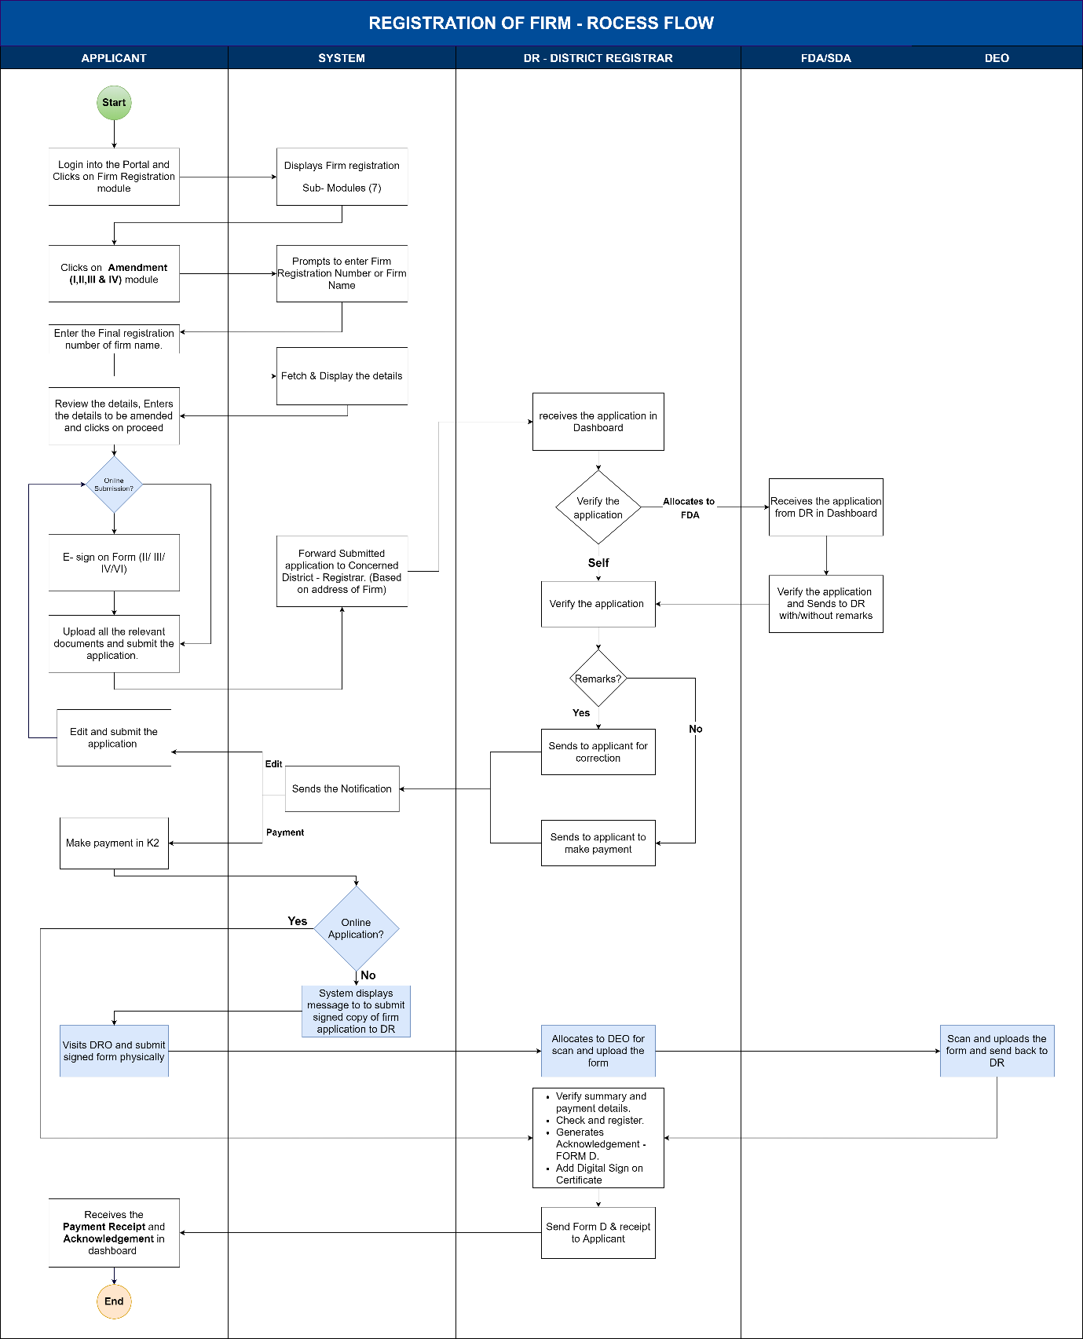
Figure 4: Process flow for Amendments

Functional Requirement Specifications
Stakeholder/ Interface | Role/ Responsibilities
Applicant (Partner or Agent) | - Login, enter the Firm registration number and fetch the details.  - Verify and change the necessary details.  - E-Sign on Summary:  - For amendment I: Form - II  - For amendment II: Form - III  - For amendment III: Form - IV  - For amendment IV: Form - VI  - Upload Relevant Documents  - Edit the application and re-submit based on DR remarks (if required)  - Payment of fees  - Collect Fee Receipt  - Collect Digitally Signed Form – D:  Memorandum Acknowledging Receipts of Documents
DFDA/DSDA | - Verification of the Application Summary.  - Verification of the documents Submitted.  - Add Remarks (If Any).  - Send back to DR for verification.
DR | - Verification of the Application Summary.  - Verification of the documents Submitted.  - Add Remarks (If Any).  - Send it back to the applicant for payment.  - Approval of Registration in the System.  - Issuance of Digitally signed Acknowledgement.
System | - Validations including Firm name (the system should check the name as per objectionable names and emblem act), fee payment, and place of firm  - Select the DRO of the jurisdiction where the principal place of the firm is located.  - Calculation of Fee.  - Generation and Print Acknowledgment (Form D) and Fee Receipt (Form E)  - Updating the Register of Firms and its Index  - Accounting entry for each transaction in A-Register  - Generation of MIS Reports
Process Triggers | - Receiving application at DR Office
Process Description | Bird's view of the amendment of the registered firm  Amendment of registered firms has eight screens for the applicant to submit the application, which captures details as shown below table:  Amendment of registered firms consists of 7 screens for DR to generate the acknowledgement,  Amendment consists of 1 screen for DFDA/DSDA to verify the application and send it back to DR:  The detailed flow is explained in the FRS table below.  Amendment consists of 1 screen for DEO to verify the application and send it back to DR:  The detailed flow is explained in the FRS table below.  Process Flow  Application Filing (Applicant/Agent):  - Application to be filed in the Kaveri 2.0 Portal  - Select the Service required. The services provided are  - Registration of New Firm  - Amendment of Registered Firm  - Re-Constitution of Firm  - Dissolution of Firm  - Protest Entry  - Index Search  - Certified Copies  For Amendment of Registered Firm, Applicant must enter the Following Details to fetch the details of the firm:  - The Firm registration number (mandatory) alphanumeric fields with only allowed special characters is “-” and the allowed characters are 20.  OR  - Firm Name (mandatory fields) alphanumeric fields with all the special characters allowed up to 250 characters.  - System displays the existing name and principal place of business of the firm and the applicant clicks on ‘Proceed’ to proceed further.  - System should display the type of amendments (Forms II, III, IV, and VI)  - Selection type of amendment radio buttons  - Form II: Amendment I: Firm Name/Principal place of business/ Nature of business  - Form III: Amendment II: Change in the place of business other than the principal place of business  - Form IV: Amendment III: Alteration in Name or Permanent Address of Partner  - Form VI: Amendment IV: Notice of election by Minor Partner admitted to the benefit of partnership on attaining majority  After selection, the applicant clicks on the ‘Proceed’ button.  Note: Applicant can do only one amendment at a time, until the current amendment is over applicant will not be able to apply to another amendment.  Update Details  For Amendment I: Firm Name/Principal place of business/ Nature of business  - Applicant chooses Form II: Amendment I  - System displays the Current Name, and Principal place of business on LHS and there will be a provision to enter new details on RHS.  - Applicant enters new/amended name of the firm (if any)  - If the firm’s name contains objectionable names as per the Emblem Act, it should not proceed; the system should prompt an error message and ask the applicant to change the name.  - If the firm’s name is the same as the existing firm’s name in the firm index, then the system shall ask for a change in the name of the firm.  - Applicant enters a new principal place of business (if there is any change):  House No./Building Name (250 characters, all the special characters are allowed), Street Address, State, District, Taluka, Hobli/Ward, Village/City, Pin code (all are mandatory fields), and should be in Karnataka only. Clicks on the Proceed button  - Date of amendment (Calendar)  - Applicant must choose a Presenter from the dropdown with the list of partners.  - If the Presenter is one of the Partners of the firm, then the data should be auto-fetched by the system from the New Firm Registration Module upon the selection of the partner.  - Applicant should select whether the presenter is represented by an agent or not.  - If the presenter is represented by his authorised agent, a provision is to be made to enter the details of the agent along with an option to upload the GPA in PDF format not exceeding the size of 5MB.  Witness details  The witness must be either a Gazette Officer, Advocate, Attorney, Vakil, Honorary Pleader, Chartered Accountant, or Registered State Auditor. Their profession must be captured.  - Choose partners to identify (mandatory) from the dropdown which contains the name of partners.  - Name of the witness  - Salutation (mandatory field) (Ex: Sri., Smt., M/S, Mr., Mrs., Ms., Kumari., Kumara).  - First Name (mandatory field), Middle Name, Last Name (optional)  - Date of Birth (calendar) (mandatory field)  - Age (in years) should be auto-calculated once DOB is entered; The system should register only if age>=18 years)  - Gender (mandatory field) Radio Button – Male, Female and Transgender  - Profession (dropdown) (mandatory field)  - Gazetted officer  - Advocates  - Magistrate  - Notary public  - attorney of the High Court  - Pleader  - Charged Accountants  - Restricted State Auditor  - Sales Tax Act Practitioner  - Income Tax Act Practitioner  - Mobile Number (mandatory field) numeric field of 12 characters.  - Email ID (optional field) alphanumeric field with special characters with email ID format validation.  - Address – Only permanent address to be captured  House No./Building Name (250 characters, all the special characters are allowed), Street Address, State, District Taluka, Hobli/Ward, Village/City, Pin code (all are mandatory fields)  (Note: The address can be anywhere across the country  A witness can identify any number of partners, but a partner can be identified by exactly one witness.)  - Once the applicant selects the presenter and clicks on the ‘Continue’ button system should display the summary of the amendment made on a split screen in which LHS displays the current details of the firm and RHS displays the amended details of the firm.  - Applicant reviews the data entered, and he is provided with three options:  - Use the edit button at this stage to make changes (if necessary).  - Sign online (which displays Form II upon clicking)  - E-sign to complete the signatures of all the partners/agents and witness digitally.  - Close to come back to the summary page.  - Sign offline: which displays Form II upon clicking with the message “This Application form should be duly signed and submitted to District Registrar Office upon successful verification” to take the print and manually sign and submit the application to DR office.  - The applicant should be redirected to the application to upload relevant documents (in PDF format, which allows up to 5MB).  - Address Proof (Sale Deed / Rental Agreement / Tax Paid Receipt)  - ID Proof of the Presenter (Driving License / PAN / Voter ID (EPIC Card) / Aadhar Card / Passport)  - Supporting Documents (if any – Optional)  - Applicant must view the fee table and click on Submit.  - System should send an SMS to the applicant in the below format  “Your FIRM application (FORM II) is submitted successfully to the DRO Office name with application number xxx. From: Department of Stamps and Registration.”  - Upon the acknowledgement of the application by DR, the applicant must make the fee payment online.  - After the DR checks and register the changes, the applicant can download the from E: Fee Receipt as well as the Form D: Memorandum Acknowledging Receipts of Documents.  For Amendment II: Change in the place of business other than the principal place of business.  - Applicant chooses Form III: Amendment II  - System displays the details in a split screen, on LHS Existing Name, Nature of Business, and Principal Place of Business along with existing Other Place of Business (if any), and on RHS, there will be two options,  - To Create: Other Place of Business.  - In case the applicant selects the create option, then the system should capture the below details  Address: House No./Building Name (250 characters, all the special characters are allowed), Street Address, State, District, Taluka, Hobli/Ward, Village/City, Pin code (all are mandatory fields).  Note: Other places of business can be anywhere in India, and suitable changes in the field must be taken care.  - Date of starting the business at the current place. (Calendar)(mandatory) The Date of starting a new other place of business cannot be before the date of the constitution.  - To Delete: Other Place of Business.  - In case if the applicant selects delete options  - The system should show all the other places of business with a check box.  - When the applicant selects a particular other place of business, the system should capture the Date of Closure. (Calendar)(mandatory) date of closure should not be before the date of the constitution and not beyond the current date.  - Applicant must choose a Presenter from the dropdown with a list of partners.  - If the Presenter is one of the Partners of the firm, then the data should be auto-fetched by the system from the New Firm Registration Module upon the selection of the partner.  - Applicant should select whether the presenter is represented by an agent or not. Radio buttons with ‘Yes’ or ‘No’ to be provided.  - If the presenter is represented by his authorised agent, a provision is to be made to enter the details of the agent along with an option to upload the GPA in PDF format not exceeding the size of 5MB.  - Otherwise, the partner details are to be fetched.  - Mobile Number (mandatory field) numeric field of 120 characters.  - Email ID (optional field) alphanumeric field with special characters with email ID format validation.  - Address – Only permanent address to be captured  House No./Building Name (250 characters, all the special characters are allowed), Street Address, State, District Taluka, Hobli/Ward, Village/City, Pin code (all are mandatory fields)  (Note: The address can be anywhere across the country  A witness can identify any number of partners, but a partner can be identified by exactly one witness.)  - Once the applicant selects the presenter and clicks on the Continue button system should display the summary of the amendment made in a split screen in which LHS displays the current details of the firm and RHS displays the amended details of the firm along with uploaded documents.  - Applicant reviews the data entered, and he is provided with two options:  - Use the edit button at this stage to make changes (if necessary).  - Sign online (which displays Form III upon clicking)  - E-sign to complete the signatures of the presenter digitally.  - Close to come back to the summary page.  - Sign offline: which displays Form III upon clicking with the message “This Application form should be duly signed and submitted to District Registrar Office upon successful verification” to take the print and manually sign and submit the application to the DR office  - The applicant should be redirected to the application to upload relevant documents (in PDF format, which allows up to 5MB).  - Address Proof of other place of business (Sale Deed / Rental Agreement / Tax Paid Receipt)  - ID Proof of the Presenter (Driving License / PAN / Voter ID (EPIC Card) / Aadhar Card / Passport)  - Supporting Documents (if any – Optional)  - Applicant has to view the fee table and click on ‘Submit’.  - System should send an SMS to the applicant in the below format  “Your FIRM application (FORM III) is submitted successfully to the DRO Office name with application number xxx. From: Department of Stamps and Registration.”  - Upon the acknowledgement of the application by DR, the applicant must make the fee payment online.  - After the DR checks and register the changes, the applicant can download the Form E: Fee Receipt as well as the Form D: Memorandum Acknowledging Receipts of Documents.  For Amendment III: Alteration in Name or Permanent Address of Partner  - Applicant chooses Form IV: Amendment III  - System displays the details in a split screen. On LHS Firm Name and Principal Place of Business. Name and Address details of the partners will be displayed and on RHS, the system provides an option to update the name and permanent address of existing partners.  - Applicant should select the name of the partner(s) from the list of partners provided in the dropdown with the check box option.  - Details related to one partner can be updated and saved at a time.  - Name of the Partner  Salutation (dropdown) (Ex: Sri., Smt., M/S, Mr., Mrs., Ms., Kumari., Kumara) (mandatory field)  - First Name, Middle Name, Last Name (only First Name is mandatory field, Middle and Last Name are optional) 50 characters allowed.  - Permanent Address –  House No./Building Name (250 characters, all the special characters are allowed), Street Address, State, District Taluka, Hobli/Ward, Village/City, Pin code (all are mandatory fields)  (Note: Address can be anywhere across the country)  - Date of Amendment (calendar)  - The system displays the Names and permanent Addresses of the existing partners and updated details.  - Applicant clicks on the ‘Continue’ button to proceed further.  - Applicant should select the presenter is represented by an agent or not.  - If the presenter is represented by his authorized agent, a provision is to be made to enter the details of the agent along with an option to upload the GPA in PDF format not exceeding the size of 5MB.  - Once the applicant selects the presenter and clicks on the Continue button system should display the summary of the amendment made on a split screen in which LHS displays the current details of the firm and RHS displays the amended details of the firm.  - Applicant reviews the data entered and he is provided with two options:  - Edit button at this stage to make changes (if necessary).  - Sign online (which displays Form IV upon clicking)  - E-sign to complete the signatures of all the partners digitally.  - Close to come back to the summary page.  - Sign offline: which displays Form IV upon clicking with message “This Application form should be duly signed and submitted to District Registrar Office upon successful verification” to take the print and manually sign and submit the application to DR office.  - The applicant should be redirected to the application to upload relevant documents (in PDF Format allowed up to 5MB).  - Address proof of Partner  (Sale Deed / Rental Agreement / Tax Paid Receipt)  - ID Proof of the Partner, Agent, Witness and Presenter  (Driving License / PAN / Voter ID (EPIC Card) / Aadhar Card / Passport)  - Supporting Documents (if any – Optional)  - Applicant must view the fee table and click on Submit.  - System should send an SMS to the applicant in the below format  “Your FIRM application (FORM IV) is submitted successfully to the DRO Office name with application number xxx. From: Department of Stamps and Registration.”  - Upon the acknowledgement of the application by DR, the applicant must make the fee payment online.  - After the DR checks and registers the changes, the applicant can download Form E: Fee Receipt as well as Form D: Memorandum Acknowledging Receipts of Documents.  For Amendment IV: Notice of election by Minor Partner admitted to the benefit of partnership on attaining majority.  - Applicant chooses Form VI: Amendment IV  - System displays the details in a split screen, on LHS existing Firm Name and address of the Principal Place of Business, and on RHS system displays a dropdown with a list of minor partners who are attaining or attained majority on the date of amendment.  - Applicant selects the minor partner form dropdown (who attains the majority) and clicks on Proceed.  - System displays the Name and Address of the minor partner.  - Partner continuation status. (mandatory) radio button YES, NO.  - If the selection is yes, then the system should collect the address of the partner  - Address of Partner:  House No./Building Name (250 characters, all the special characters are allowed), Street Address, State, District, Taluka, Hobli/Ward, Village/City, and Pin code (all are mandatory fields).  - The date of election (Calendar) for becoming a partner should be entered by the applicant (mandatory). This date of discontinuation cannot be before the date of the constitution and cannot be beyond the current date  - If No is selected, then the Discontinuation Date (Calendar) should be entered by the applicant (mandatory) calendar. This date of discontinuation cannot be before the date of the constitution and cannot be beyond the current date.  - If the difference between the date of submission and the date of election or discontinuation is more than 6 months then the minor partner who’s attaining majority is to be assumed as partner.  - Applicant should select whether the partner is represented by an agent or not.  - If the presenter is represented by his authorised agent, a provision is to be made to enter the details of the agent along with an option to upload the GPA in PDF format not exceeding the size of 5MB.  - Mobile Number (mandatory field) numeric field of 12 characters.  - Email ID (optional field) alphanumeric field with special characters with email ID format validation.  - Address – Only permanent address to be captured  House No./Building Name (250 characters, all the special characters are allowed), Street Address, State, District Taluka, Hobli/Ward, Village/City, Pin code (all are mandatory fields)  (Note: Address can be anywhere across the country.)  - After entering witness details, the applicant selects the presenter and clicks on the ‘Continue’ button system should display the summary of the amendment made on a split screen in which LHS displays the current details of the partner and RHS displays the amended details of the partner.  - Applicant reviews the data entered and he is provided with three options:  - Edit button at this stage to make changes (if necessary).  - Sign online (which displays Form VI upon clicking)  - E-sign to complete the signatures of all the partners digitally.  - Close to come back to the summary page.  - Sign offline: which displays Form VI upon clicking with the message “This Application form should be duly signed and submitted to District Registrar Office upon successful verification” to take the print and manually sign and submit the application to the DR office later.  - The applicant should be redirected to the application to upload relevant documents (in PDF format, which allows up to 5MB).  - Address Proof partner (Sale Deed / Rental Agreement / Tax Paid Receipt)  - ID Proof of Minor Partner (Driving License / PAN / Voter ID (EPIC Card) / Aadhar Card / Passport / Birth Certificate)  - Age Proof for Minor Partner attained Majority (Aadhar Card / Birth Certificate / Passport)  - ID Proof of the Presenter (Driving License / PAN / Voter ID (EPIC Card) / Aadhar Card / Passport)  - Supporting Documents (if any – Optional)  - Applicant must view the fee table and click on Submit.  - System should send an SMS to the applicant in the below format  “Your FIRM Amendment application (FORM VI) is submitted successfully to the DRO Office name with application number xxx. From: Department of Stamps and Registration.”  - Upon the acknowledgement of the application by DR, the applicant must make the fee payment online.  - After the DR checks and registers the changes, the applicant can download the Form E: Fee Receipt as well as Form D: Memorandum Acknowledging Receipts of Documents  Relevant documents to be uploaded:  - For Amendment I:  Address Proof of Firm –  If the Principal Place of Business is owned by the firm, then, Tax Paid Receipt or Sale deed copy can be accepted as Address Proof and if it is rented, a duly stamped Rental Agreement copy is to be provided.  - For Amendment II:  Address Proof of other place of business – If the place of Business is owned by the firm, then, a Tax Paid Receipt or Sale deed copy can be accepted as Address Proof, and if it is rented, a duly stamped Rental Agreement copy is to be provided.  - For Amendment III:  Proof of Identity (for each partner)  o Aadhar Card  o PAN Card  o Driving License  o Passport  o EPIC Card (Voter ID)  Proof of address (for each partner)  o Aadhar Card  o Driving License  o Passport  o EPIC Card (Voter ID)  o Duly stamped Rental Agreement (in case of rented house)  - For Amendment IV:  Proof of Identity (for a minor partner who is attaining majority)  - Aadhar Card  - PAN Card  - Driving License  - Passport  - EPIC Card (Voter ID)  - Birth Certificate  Proof of address (for a minor partner who is attaining majority)  - Aadhar Card  - Driving License  - Passport  - EPIC Card (Voter ID)  - Duly stamped Rental Agreement (in case of rented house)  - Witness Documents:  Proof of Identity  - Aadhar Card  - PAN Card  - Driving License  - Passport  - EPIC Card (Voter ID)  Proof of address (for a minor partner who is attaining majority)  - Aadhar Card  - Driving License  - Passport  - EPIC Card (Voter ID)  - Duly stamped Rental Agreement (in case of rented house)  - Additional supporting document (if any) (optional)  - Supporting Document 1  - Supporting Document 2  Fee and Penalty Calculation (System)  - Fees for Recording of Amendment I:  The System shall calculate and display the fee for processing the application  - Amendment Fee = Rs.50 (fixed)  - Application Fee = Rs.1 (fixed)  - Total Payable Amount (in Rs.) = 51  - Fees for Recording of Amendment II:  The System shall calculate and display the fee for processing the application  - Amendment Fee = Rs.25 (fixed)  - Application Fee = Rs.1 (fixed)  - Total Payable Amount (in Rs.) = 26  - Fees for Recording of Amendments III & IV:  The System shall calculate and display the fee for processing the application  - Amendment Fee = Rs.25 (fixed)  - Application Fee = Rs.1 (fixed)  - Total Payable Amount (in Rs.) = 26  - Applicant shall view the fee details and submit the application.  - For all types of amendments, if the date of notice to DR is within 90 days, then no penalty.  - Case-1: The date of the amendment is 20-01-2024 and the date of the notice is 16-04-2024  - Notice is given within 90 days (exactly on the 87th day), hence no penalty.  - Case-1: The date of the amendment is 20-01-2024 and the date of the notice is 25-04-2024  - Notice is given after 90 days (exactly on the 96th day)  - So, the total number of days crossed after 90 days is six days.  - Hence, 6*10= INR 60 to be added as a penalty.  Application Verification by DR (self-verification):  - DR clicks on the ‘Verify’ button. In this case, there are no DFDA/DSDA Remarks on the UI.  - The DR Self verifies the application Summary, Forms, deed copy, and other enclosures as mentioned below in Table 3: Points to be verified.  - The DR will select one of the two options,  - Send to applicant for correction - DR shall add his/her remarks, click on the ‘Send to Applicant’ button for correction, and resend the application  - System should send an SMS in below format  “Your FIRM Amendment application xxx (FORM II/III/IV/VI) submitted to DRO Office name has been sent back with remarks. From: Department of Stamps and Registration.”  - Send to applicant for payment - If no remarks, DR clicks on the ‘Send to Applicant’ button to make payment  - System should send an SMS in below format  “Your FIRM Amendment application xxx (FORM II/III/IV/ VI) submitted to DRO Office name has been verified and sent for payment from the Department of Stamps and Registration.  Allocation to DFDA/DSDA:  - The DR allocates the firm application to DFDA/DSDA by clicking on the ‘Allocate’ button.  Verification by DFDA/DSDA:  - The DFDA/DSDA shall start the verification process by selecting the ‘Start Verification’ button  - The DFDA/DSDA Application verification screen is split into 2 sides:  - LHS (Left-hand side of the page) – the Summary sheet containing all the details that the Applicant has entered (firm details, partner details, witness details), a section to add his remarks, and a button to send it back to the DR  - RHS (Right-hand side of the page) – contains the E-Signed Amendment Form – II/ III / IV / VI and uploaded documents by the Applicant, which are Forms and other Enclosures  - The DFDA/DSDA shall crosscheck the application(s) and the enclosures thoroughly; DFDA/DSDA fill a checklist (as per Annexure 3) mentioning remarks for each category –  Table 3: Points to be verified.  - DFDA/DSDA sends it back to the DR with/ without remarks by clicking on ‘Send back to DR’ for approval  DR – Received from DFDA/DSDA:  - After the application is received from DFDS/DSDA, the DR shall log in and view the remarks made by DFDA/DSDA by clicking on the ‘View’ button.  - DR shall add his/her remarks, click on the ‘Send to Applicant’ button for correction, and resend the application  - System should send an SMS in below format  “Your FIRM Amendment application xxx (FORM II/III/IV/ VI) submitted to DRO Office name has been sent back with remarks. From: Department of Stamps and Registration.”  - If there are no remarks, DR clicks on the ‘Send to Applicant’ button to make the payment  - System should send an SMS in below format  “Your FIRM Amendment application xxx (FORM II/III/IV/ VI) submitted to DRO Office name has been verified and sent for payment. From: Department of Stamps and Registration.”  Payment:  - After DR accepts and approves the application, the applicant shall log in to the Kaveri 2.0 portal and make the Payment of Fee (Total Payable Amount) online through the Khajane II portal by clicking on the ‘Make Payment’ button.  - The system should show the calculated fee (freeze it, and the applicant can make no changes at this stage) before the applicant makes the payment and then give the ‘Make Payment’ option)  - Once the citizen makes the payment, the system will send an SMS in the below format  “Your FIRM Amendment application xxx (FORM II/III/IV/ VI) is submitted to DRO Office name with Sakala number IGxxxx it will be processed in x working days. From: Department of Stamps and Registration.”  Amendment:  - Online applications: Applicants who have E-signed the application need not visit the DR office. After making the payment, the application will proceed to DR login for Check and Register.  - Offline applications: Applicants who have not E-signed the application. Need to submit the manually signed application to the DR office. In such cases DR will allocate the application to DEO for scanning and uploading the application form.  - The DR will verify the application summary, forms, deed copy, other enclosures, and payment details, then click on ‘Check and register’.  - The System generates an acknowledgement copy and makes an entry in the register of firms  - The system pushes the application to the next step in DR login.  - The DR will click on the "Generate Certificate" button and digitally sign Form D: memorandum acknowledging receipts of documents.  - The system sends Form E: payment receipt and digitally signed Form D: Acknowledgement to the applicant's login for downloading.  - The system should send an SMS in the below format  “Your FIRM Amendment application xxx (FORM II/III/IV/VI) has been acknowledged at the DRO Office (name). Please log in to your account to download the Acknowledgment. From: Department of Stamps and Registration.”  Accounting:  - System updates the index of Firms and A-Register  - Details logged in the A-Register are as follows:  - Date of alteration  - Type of alteration.  - Fee Collected.  - Fee Receipt Number.
  Screens | Details captured
  Firm Registration Number | - Firm Number or Firm Name
  Firm Details | - Displays auto-fetched firm details.
  Choose the type of amendment | - Amendment (I, II, III or IV)  - Enter the amended details to be notified  (Firm Name or Nature of Business or Principal Place of Business or ALL)
  Presenter details | - Presenter selection(partner/agent).
  Review Summary | - Review the form (II, III, IV or VI)  - Manually Sign/E-sign of the partner(s)/agent(s) and Witness(es).
  Upload documents | - Proof of identity of Presenter.  - Proof of address (firm) if there is a change in the address of the firm.  - Supporting document (If any)
  Submit | - View fees  - Submit (SMS will be sent to the applicant)
  Make Payment | - Applicant views the application reviewed by DR.  - Makes payment via. Khajane-II to the department.
  Screen | Details captured
  Dashboard | - Selection of the firm application
  Firm module DR Step-1 | - Applications received from applicants.  - Allocation to DFDA or DSDA or,  - Self-verification of applications.  - Allocate to DEO for Scanning and Uploading the application form-2.
  Firm module DR Step-2 | - View allocated applications to DFDA/DSDA  - Reallocate the application.
  Firm module DR Step-3 | - View and re-verify the verified applications from DFDA/DSDA.
  Firm module DR Step-4 | - View DR-verified applications for payment.
  Firm module DR Step-5 | - View applications received from applicants after payment.
  Firm module DR Step-6 | - Generate amendment acknowledgement (Form D: Memorandum Acknowledging Receipts of Documents).  - Digitally sign on acknowledgement. (SMS will be sent to the applicant)  - View digitally signed acknowledgements.
  Screen | Details captured
  Firm module DFDA/DSDA Step-1 | - View applications allocated by DR.  - Verification and Send back to DR after verification.
  Screen | Details captured
  Firm module DFDA/DSDA Step-1 | - View applications allocated by DR.  - Scan and upload the Signed Application form-V and Send it back to DR after verification.
  For Amendment I | - Firm Names: Existing name and Amended name (if any)  - Principal place of business: Existing and amended (if any)
  For Amendment II | - Firm Name  - Principal place of business  - Place of business other than principal place (Opening/Closing)
  For Amendment III | - Firm Name  - Principal place of business  - Place of business other than the principal place  - Partner details (Current and amended)
  For Amendment IV | - Firm Name  - Principal place of business  - Minor partner details (Current and Amended)  - Continuation status: Continue or discontinue.
Interfaces and purpose
  System | Information Received | Information Sent
  A Register | Fees Collected, Dissolution date, Receipt Number, type of amendment, and amendment date. | Fee receipt, Acknowledgement.
  Register of Firms and its Index | Change in the Name of the Firm  Changes in the Name of the partners  Opening/closing of other place of business  Choice of minor partner who turned to major  Date of election.  Duration of firm  Registration number  Date of registration  Type of amendment  Amended details  Date of amended

5.3 Reconstitution of firm
The Reconstitution of firms consists of two distinct steps (Table 4). Citizens can register the reconstitution of the partnership deed for the reconstitution of the firm in Kaveri 2.0. The registration process follows the typical document registration flow at SRO. After registering the partnership deed, citizens can file their firm at Kaveri 2.0 by submitting the application.
The registration process follows the Typical document registration Flow at SRO (Figure 3).
Sl. No. | Action required | Actors | Statutory provisions
1 | Document Registration of Reconstitution Deed  Under 40(B) of Stamp Act | SRO | The Karnataka Registration Act, 1908  Karnataka Stamp Act, 1957
2 | Reconstitution of firm  Under section 31&32 of the Partnership Act | DRO | The Indian Partnership Act, 1932
Table 4 Firm Re-constitution

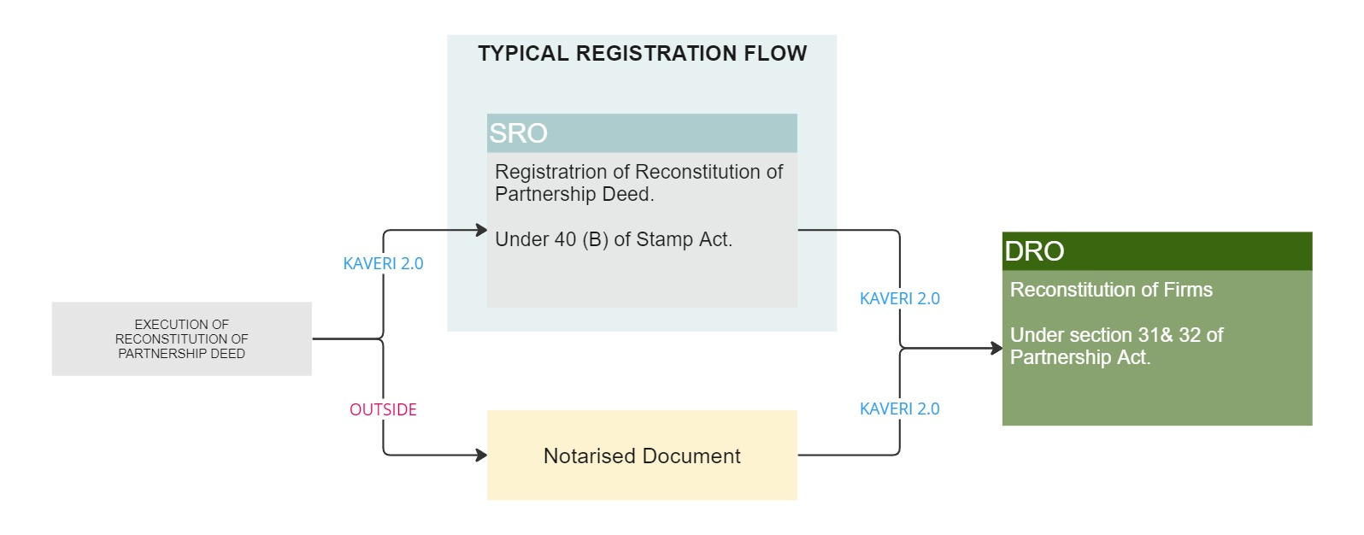
Figure 3 Reconstitution of firm

Process Flow
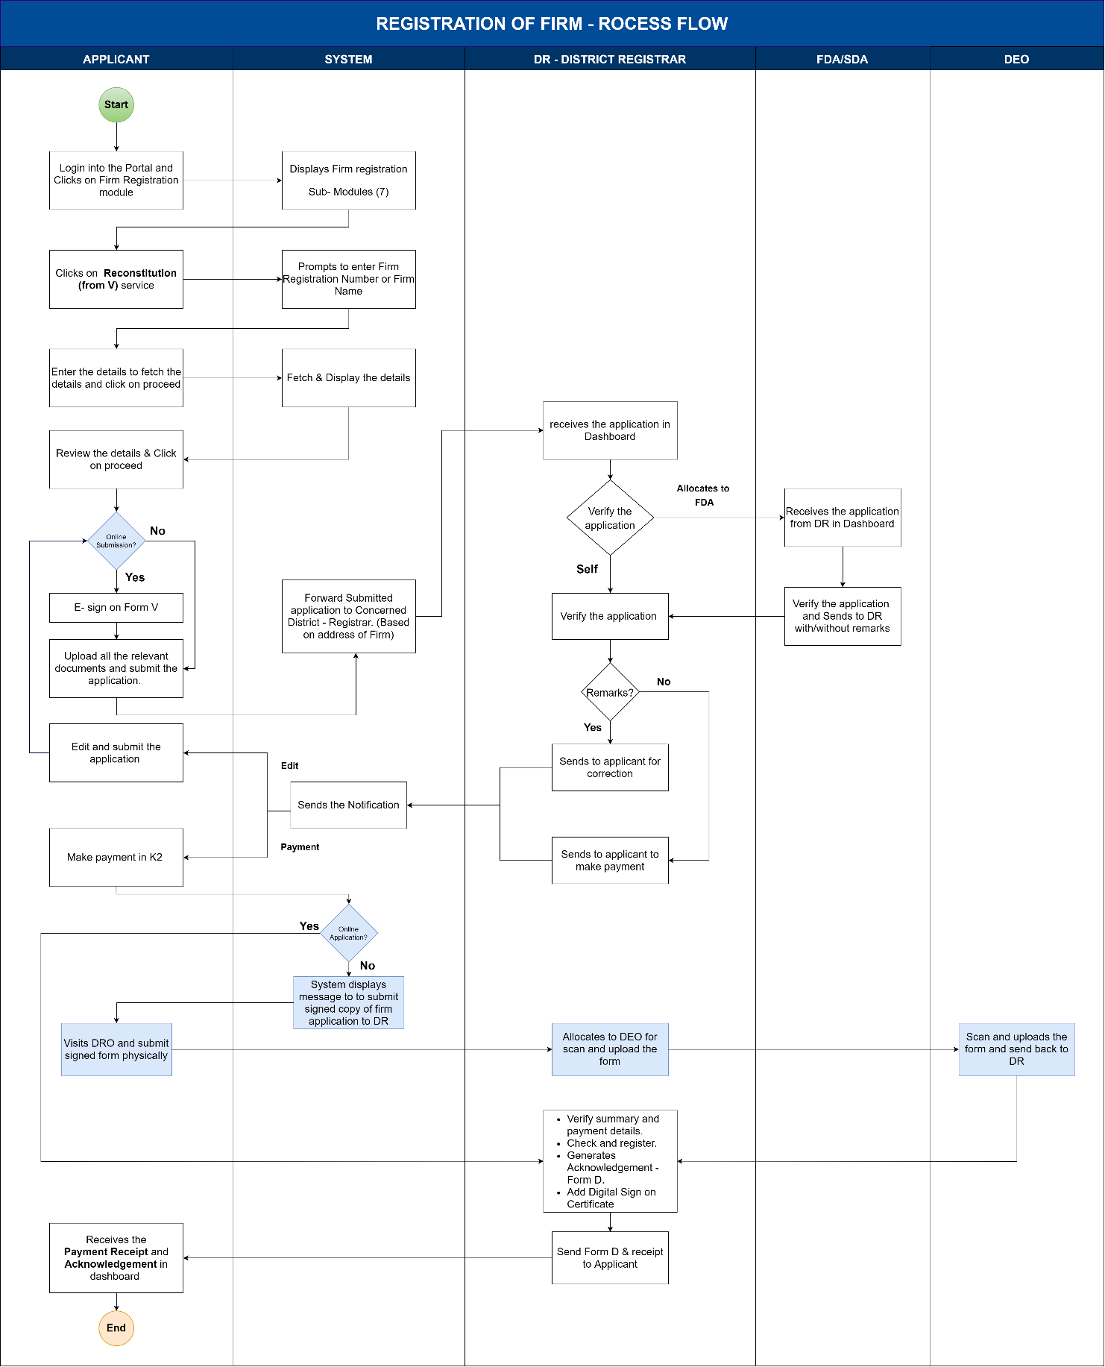
Figure 5: Process flow for Reconstitution

Functional Requirement Specifications
Stakeholder/ Interface | Role/ Responsibilities
Applicant  (Partner or agent) | - File the application for Reconstitution of the firm  - Online Data Entry  - E-Sign on Summary: Form – V  - Upload Relevant Documents  - Make the necessary changes as per DR remarks.  - Fees Payment  - Download the digitally signed acknowledgement and fee receipt
DFDA/DSDA | - Verification of the application Summary  - Verification of the documents Submitted  - Add Remarks (If Any)  - Send back to DR for verification.
DR | - Verification of the application Summary or allocation of application to DFDA/DSDA for verification.  - Verification of the documents Submitted  - Reverification of DFDA/DSDA Verified applications.  - Add Remarks (If Any)  - Send it back to the applicant for payment (If there are no remarks).  - Send the application back to edit the application (If there are no remarks).  - Approval of Registration in the System  - Authentication of Firm Reconstitution or Digital Sign.
System | - Retrieve the Firm details upon entering the Final registration number or Firm Name.  - Select the DRO of the Jurisdiction where the principal place of the firm is located.  - Calculation of Fees.  - Generate and Print Acknowledgment (form D) and Fee Receipt (form E)  - Updating the Register of Firms and Its Index  - Accounting entry for each transaction in A-Register  - Generation of MIS Reports
Process Triggers | - Receiving application at DR Office
Process Description | Application Filing:  - Application to be filed in the Kaveri 2.0 Portal  - Select the Service required. The services provided are  - Registration of New Firm  - Amendment of firm  - Re-Constitution of Firm  - Dissolution of Firm  - Protest Entry  - Index Search  - Certified Copies  For Reconstitution of the Registered Firm, the Applicant must enter the Following Details to fetch the details of the firm:  - The firm registration number (mandatory) for alphanumeric fields with only allowed special characters is “-” and the allowed characters are 20.  OR  - Firm Name (mandatory fields) alphanumeric fields with all the special characters allowed up to 250 characters.  - System displays the existing name and principal place of business of the firm and the applicant clicks on ‘Proceed’ to proceed further.  Update Details  - For Firm Reconstitution, the Applicant must choose the type of reconstitution:  - Outgoing Partner  - Incoming Partner.  If the selection of the applicant is an Outgoing partner:  - Applicant must select the outgoing partner from the dropdown.  - System should fetch and display details of outgoing partner.  - Applicant should enter the Date of Deceasing Partner. (Calendar) (mandatory field). The date should not be before the date of the constitution or beyond the current date.  - Affidavit: A notarised affidavit on INR 100 E-stamp paper to be uploaded for the deceased partner(s)  If the selection of applicant Incoming partner  The system will display the below fields to capture the new partner details.  - Name of the Incoming Partner  - Salutation (dropdown) (Ex: Sri., Smt., M/S, Mr., Mrs., Ms., Kumari., Kumara) (mandatory field)  - First Name, Middle Name, Last Name (only First Name is mandatory field)  - Relationship (dropdown) (Ex: Daughter of, Son of, Care of) (mandatory field)  - Relative Name (manually enter data) 250 characters, no special characters are allowed (mandatory field) (mandatory field)  - Date of Birth (calendar) (mandatory field)  - Age (in years) should be auto-calculated once DOB is entered,  - Even a minor can be a partner. In the case of a minor partner, guardian details are to be collected as below,  Name of the Minor guardian  - Salutation (dropdown) (Ex: Kumari., Kumara) (mandatory field)  - First Name, Middle Name, Last Name (only First Name is mandatory field, Middle and Last Name are optional) 50 characters allowed.  - Relationship (dropdown) (Daughter of, Son of, Care of) (mandatory field)  - Relative Name (manually enter data) 250 characters. No special characters are allowed (mandatory field)  - Date of Birth (calendar) (Mandatory field)  - Age (in years) should be auto-calculated once DOB is entered  - Gender (mandatory field) Radio Buttons – Male, Female, Transgender  - Occupation (optional field) 50 characters allowed  - Mobile Number (mandatory numeric field of 12 characters.  - Email ID (optional field) alphanumeric field with special characters with email ID format validation.  - Address –  House No./Building Name (250 characters, all the special characters are allowed), Street Address, State, District Taluka, Hobli/Ward, Village/City, Pin code (all are mandatory fields)  Note: Address can be anywhere across the country  - Gender (mandatory field) Radio Buttons – Male, Female, Transgender  - Occupation (optional field) 50 characters allowed  - Mobile Number (mandatory) numeric field of 12 characters.  - Email ID (optional field) alphanumeric field with special characters with email ID format validation.  - Date of Joining (calendar) (mandatory field) validation should be given to check the date of joining/ceasing, which should not be before the date of the firm constitution.  - Address –  House No./Building Name (250 characters, all the special characters are allowed), Street Address, State, District Taluka, Hobli/Ward, Village/City, Pin code (all are mandatory fields)  (Note: Address can be anywhere across the country.  Provide for the ‘same as above’ button; if checked, then the Permanent Address should be auto-fetched from the Current Address.  - Is the partner represented by the agent?  (Yes or No radio buttons should be provided. If Yes is selected, then the applicant has to upload the GPA / Supporting Document for the agent. The same details should be auto-fetched in the presenter’s tab when the agent’s name is selected as the Presenter. If Yes is selected, the system should collect the details of the agent as they are now collected in the Presenter’s Details.)  - Mobile Number (mandatory field) numeric field of 12 characters.  - Email ID (optional field) alphanumeric field with special characters with email ID format validation.  - Address – Only permanent address to be captured  House No./Building Name (250 characters, all the special characters are allowed), Street Address, State, District Taluka, Hobli/Ward, Village/City, Pin code (all are mandatory fields)  (Note: The address can be anywhere across the country  A witness can identify any number of partners, but a partner can be identified by exactly one witness.)  - After entering witness details, the applicant reviews the data entered, and he is provided with two options:  - Use the edit button at this stage to make changes (if necessary).  - Sign online (which displays Form V upon clicking)  - E-sign to capture the signature,  - Case-1: For an incoming partner case, an E-sign of the Incoming partner or agent is required.  - Case 2: For outgoing partners, an E-sign of an Outgoing partner or agent is required.  - Case 3: For both incoming and outgoing cases, the E-sign of both incoming and outgoing partners or their agents’ signatures are required.  - Close to come back to the summary page.  - Sign offline: which displays Form V upon clicking with a message “This Application form should be duly signed and submitted to District Registrar Office upon successful verification” to take the print and manually sign and submit the application to DR.  - The applicant should be redirected to the application to upload relevant documents (in PDF format, which allows up to 5MB).  - Applicant must view the fee table and click on Submit.  - System should send an SMS to the applicant in the below format  “Your FIRM application (FORM V) is submitted successfully to DRO Office (name) with application number xxx. From: Department of Stamps and Registration.”  - Upon the acknowledgement of the application by DR, the applicant must make the fee payment online.  After the DR checks and register the changes, the applicant can download Form E: Fee Receipt as well as Form D: Memorandum Acknowledging Receipts of Documents.  Applicant must Upload the Following Documents:  Firm related Documents:  - Reconstitution Deed (mandatory)  - Document Number (mandatory)  - Affidavit (mandatory): Notarized affidavit on ₹100/- E Stamp paper swearing that he has not contributed any immovable property to the firm and not taking away any immovable property from the firm.  Incoming Partner-related Documents:  - Proof of Identity (for each Incoming partner)  - Aadhar Card  - PAN Card  - Driving License  - Passport  - EPIC Card (Voter ID)  - Proof of address (for each Incoming partner)  - Aadhar Card  - Driving License  - Passport  - EPIC Card (Voter ID)  Witness Related Documents:  - Proof of Identity  - Proof of Identity Aadhar Card  - PAN Card  - Driving License  - Passport  - EPIC Card (Voter ID)  - Proof of address  - Aadhar Card  - Driving License  - Passport  - EPIC Card (Voter ID)  Supporting documents if any,  - Supporting Document 1  - Supporting Document 2  Fee Calculation (System)  - The System shall calculate and display the fee for processing the application  - Registration Fee = Rs.25 (fixed)  - Application Fee = Rs.1 (fixed)  - Total Payable Amount (in Rs.) = 26  - Applicant Shall View the Fee Details and Submit the Application  - Applicant shall view the fee details and submit the application.  - For all types of amendments, if the date of notice to DR is within 90 Days, then no penalty.  - Case-1: The date of the amendment is 20-01-2024 and the date of the notice is 16-04-2024  - Notice is given within 90 days (exactly on the 87th day), hence no penalty.  - Case-1: The date of the amendment is 20-01-2024 and the date of the notice is 27-04-2024  - Notice is given after 90 days (exactly on the 98th day)  - So, the total number of days crossed after 90 days is 8 days.  - Hence 8*10= ₹80 to be added as a penalty.  DR Self Verification:  - The DR views the application by clicking on the ‘Verify’ button and can allocate to DFDA/DSDA for verification of the received application  - The DR Self verifies the application Summary, Forms, Reconstitution deed copy, other enclosures  - Send to the applicant for correction - DR shall add his/her remarks, click on the ‘Send to Applicant’ button for correction, and resend the application  - System should send an SMS to the applicant in below format  “Your FIRM application xxx (FORM V) submitted to DRO Office name has been sent back with remarks. From: Department of Stamps and Registration.”  - Send to the applicant for payment - If no remarks, DR clicks on the ‘Send to Applicant’ button to make payment  - System should send an SMS to the applicant in below format  “Your FIRM application xxx (FORM V) submitted to DRO Office name has been verified and sent for payment. From: Department of Stamps and Registration.”  Allocation to DFDA/DSDA:  - The DR allocates the application to DFDA/DSDA by clicking on the ‘Allocate’ button  Verification by DFDA/DSDA:  - The DFDA/DSDA shall start the verification process by selecting the ‘Start Verification’ button  - The DFDA/DSDA Application Verification screen is split into two sides:  - LHS (Left-hand side of the page) – the Summary sheet containing all the details that the Applicant has entered (Fetched firm details, Outgoing and Incoming partner details, fee details), a section to add his Remarks, and a button to send it back to the DR  - RHS (Right-hand side of the page) – contains the E-Signed Form – V and Uploads by the Applicant, which are Forms and Enclosures  - The DFDA/DSDA shall crosscheck the application(s) and the enclosures thoroughly; FDA/SDA fills a Checklist mentioning Remarks for each category –  - Outgoing partner details  - Incoming partner details  - DFDA/DSDA sends it back to the DR with Remarks by clicking on ‘Send back to DR.’  DR Verification- Received from DFDA/DSDA:  - After the application is received from DFDS/DSDA, the DR shall log in and view the remarks made by DFDA/DSDA by clicking on the ‘Verify’ button.  - DR shall add his/her remarks and click on the ‘Send to Applicant’ button for correction.  - System should send an SMS to the applicant in below format  “Your FIRM application xxx (FORM V) submitted to DRO Office name has been sent back with remarks. From: Department of Stamps and Registration.”  - If no remarks, DR clicks on the ‘Send to Applicant’ button to make payment  - System should send an SMS to the applicant in below format  “Your FIRM application xxx (FORM V) submitted to DRO Office name has been verified and sent for payment. From: Department of Stamps and Registration.”  Payment:  - After DR accepts and approves the application, the applicant shall log in to the Kaveri 2.0 portal and make the Payment of the Fee (Total Payable Amount) online through the K2 portal by clicking on the ‘Make Payment’ button  - The system should show the calculated fee (freeze it, and the applicant can make no changes at this stage) before the applicant makes the payment and then give the ‘Make Payment’ option)  - The system will send an SMS to the citizen in the below format  “Your FIRM application xxx (FORM V) is submitted to DRO Office name with Sakala number IGxxxx it will be processed in x working days. From: Department of Stamps and Registration.”  Reconstitution:  - Online applications: Applicants who have E-signed the application need not visit the DR office. After making the payment, the application will proceed to DR login for Check and Register.  - Offline applications: Applicants who have not E-signed the application. Applicant need to submit manually signed application to the DR office. In such cases DR will allocate the application to DEO for scanning and uploading the application form.  - The DR will verify the application summary, forms, deed copy, other enclosures, and payment details, then click ‘Check and register’.  - The System makes an entry in the register of firms  - The system pushes the application to the next step in DR login for generating Acknowledgment.  - The DR will click the "Generate Certificate" button and digitally sign  - The system sends the Payment Receipt and digitally signed Acknowledgment to the applicant's login for download.  - The system will send an SMS to the applicant in below format  “Your FIRM Reconstitution application xxx (FORM V) has been acknowledged at the DRO Office name. Please log in to your account to download the Acknowledgment. From: Department of Stamps and Registration.”  Accounting:  - System then updates the index of Firms and A-Register  - Details logged in the A-Register are as follows:  - Registration number  - Date of Registration  - Duration of firm  - Fee Collected  - Fee Receipt number
Interfaces and purpose
  System | Information Received | Information Sent
  A Register | Fees Collected, Dissolution date, Receipt Number, | Fee receipt, Acknowledgement.
  Register of Firms and its Index | Name of the Firm  Name of the incoming and outgoing partners during reconstitution  Place of Business  Duration of firm  Registration number  Date of registration  Date of reconstitution

5.4 Dissolution of firm
Citizens can register the Dissolution of the partnership deed of the firm in Kaveri 2.0. The registration process follows the Typical document registration Flow at SRO (Figure 4).
Sl. No. | Action required | Actors | Statutory provisions
1 | Document Registration of Dissolution Deed  Under 40(C) of Stamp Act | Partner or Agent  SRO | The Karnataka Registration Act, 1908  Karnataka Stamp Act, 1957
2 | Dissolution of firm  Under section 39 of the Partnership Act | Partner or Agent  DRO | The Indian Partnership Act, 1932
Table 4 Dissolution of firm
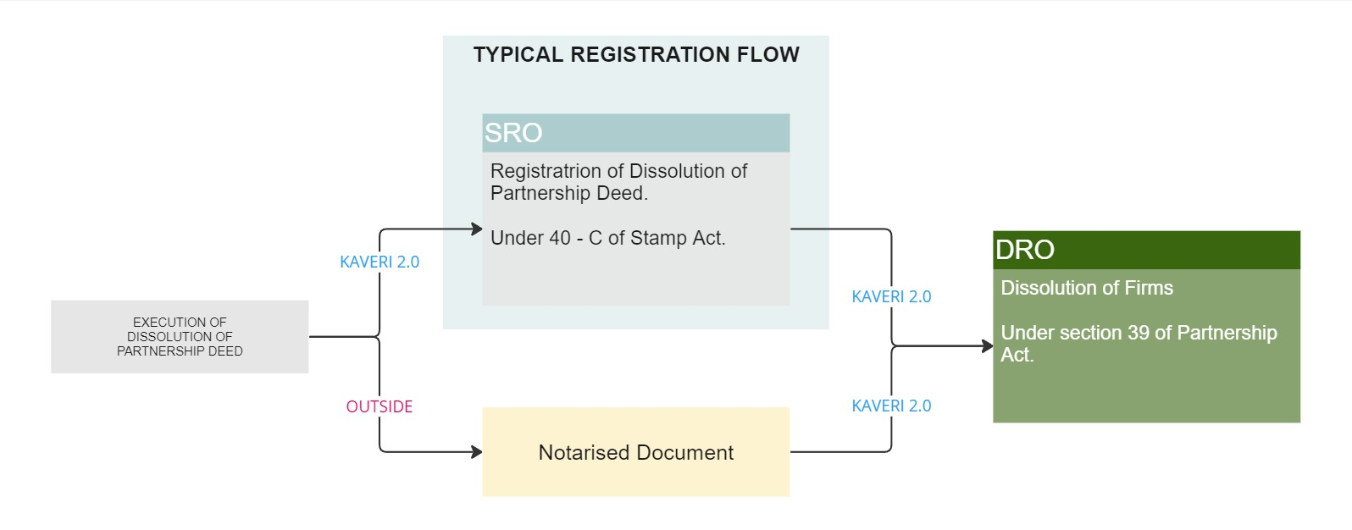
Figure 4 Dissolution of firm

Process Flow
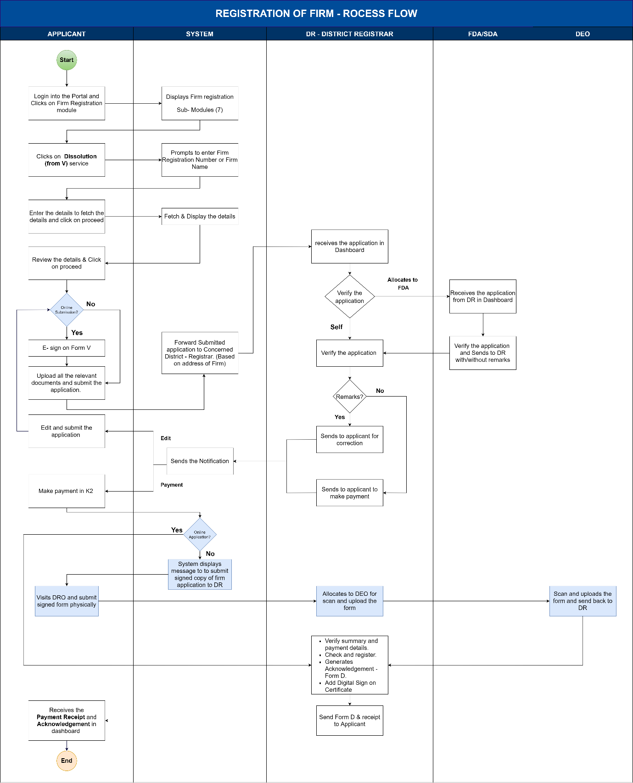
Figure 6: Process flow for Dissolution

Functional Requirement Specifications
Stakeholder/ Interface | Role/ Responsibilities
Applicant | - Apply for Dissolution of firm  - Online Data Entry  - E-Sign on Summary: Form – V  - Upload Relevant Documents  - Payment of fees  - Collect Digitally Signed Acknowledgment and Fee Receipt
DFDA/DSDA | - Verification of the application Summary  - Verification of the documents Submitted
DR | - Verification of the application Summary  - Verification of the documents Submitted  - Add Remarks (If Any)  - Send back to applicant for Payment  - Approval of Registration in the System  - Authentication of Firm Reconstitution
System | - Retrieve the Firm Details upon Final registration number  - Select the DRO of the Jurisdiction where the Principal place of the firm is Located  - Calculation of Fee  - Print Acknowledgment and Fee Receipt  - Updating in the Register of Firms and Its Index  - Accounting entry for each transaction in A-Register  - Generation of MIS Reports
Process Triggers | - Receiving application at DR Office
Process Description | Application Filing:  - Application to be filed in the Kaveri 2.0 Portal  - Select the Service required. The services provided are  - Registration of New Firm  - Amendment of firm  - Re-Constitution of Firm  - Dissolution of Firm  - Protest Entry  - Index Search  - Certified Copies  For Dissolution of Registered Firm, Applicant must enter the Following Details to fetch the details of the firm:  - The firm registration number (mandatory) for alphanumeric fields with only allowed special characters is “-” and allowed characters are 20.  OR  - Firm Name (mandatory fields) alphanumeric fields with all the special characters allowed up to 250 characters.  - System displays the Firm name and principal place of business of the firm and the applicant clicks on ‘Proceed’ to proceed further.  - Applicant must choose a Presenter from the dropdown with a list of partners.  - System should fetch and display the details.  - Applicant should select whether the presenter is represented by an agent or not.  - If the presenter is represented by his authorised agent, a provision is to be made to enter the details of the agent along with an option to upload the GPA in PDF format not exceeding the size of 5MB, and his details should be collected.  - Once the applicant enters the witness details and clicks on the Continue button, the system should display the summary.  - Applicant reviews the data, and he/she is provided with two options:  - Use the edit button at this stage to make changes (if necessary).  - Sign online (which displays Form V upon clicking)  - E-sign to complete the signatures of all the partners digitally.  - Close to come back to the summary page.  - Sign offline: which displays Form V upon clicking with a message “This Application form should be duly signed and submitted to District Registrar Office upon successful verification” to take the print and manually sign and submit the application to DR office later.  - The applicant should be redirected to the application to upload relevant documents (in PDF format, which allows up to 5MB).  - Applicant must view the fee table and click on Submit.  - The system should send an SMS to the applicant in the below format  “Your FIRM application (FORM V) is submitted successfully to the DRO Office name with application number xxx. From: Department of Stamps and Registration.”  - Upon the acknowledgement of the application by DR, the applicant must make the fee payment online.  - After the DR checks and registers the changes, the applicant can download Form E: Fee Receipt: From E as well as Form D: Memorandum Acknowledging Receipts of Documents.  Firm related Documents:  - Registered Dissolution Deed Document/ Notarised Deed Document  - Proof of Identity for presenter (Aadhar Card/PAN Card/Driving/License/Passport/EPIC Card (Voter ID)/Other)  - Proof of address for presenter (Aadhar Card/PAN Card/Driving/License/Passport/EPIC Card (Voter ID)/Other)  - Supporting Documents (if any – Optional)  Supporting Document-1  Supporting Document-2  Fee Calculation (System)  - The System shall calculate and display the fee for processing the application  - Registration Fee = Rs.25 (fixed)  - Application Fee = Rs.1 (fixed)  - Total Payable Amount (in Rs.) = 25+1  - Applicant Shall View the Fee Details and Submit the Application  - Applicant Shall View the Fee Details and Submit the Application  - Applicant shall view the fee details and submit the application.  - For all types of amendments, if the date of notice to DR is within 90 Days, then no penalty.  - Case-1: The date of the amendment is 20-01-2024 and the date of the notice is 16-04-2024  - Notice is given within 90 days (exactly on the 87th day), hence no penalty.  - Case-1: The date of the amendment is 20-01-2024 and the date of the notice is 27-04-2024  - Notice is given after 90 days (exactly on the 98th day)  - So, the total number of days crossed after 90 days is eight days.  - Hence, 8*10= ₹80 to be added as a penalty.  Application Verification (DR):  - DR should click on the button ‘Verify’ to start the verification.  - The DR Self verifies the application Summary, Forms, Dissolution deed copy, and other enclosures.  - Send to Applicant for correction - DR shall add his/her remarks, click on the ‘Send to Applicant’ button for correction, and resend the application  - The system should send an SMS to the applicant in the below format  “Your FIRM application xxx (FORM V) submitted to DRO Office name has been sent back with remarks. From: Department of Stamps and Registration.”  - Send to Applicant for payment - If no remarks, DR clicks on the ‘Send to Applicant’ button to make payment  - The system should send an SMS to the applicant in the below format  “Your FIRM application xxx (FORM V) submitted to DRO Office name has been verified and sent for payment. From: Department of Stamps and Registration.”  Allocation to DFDA/DSDA:  - The DR allocates the application to DFDA/DSDA by clicking on the ‘Allocate’ button  Verification by DFDA/DSDA:  - The DFDA/DSDA shall start the verification process by selecting the ‘Start Verification’ button  - The DFDA/DSDA Application Verification screen is split into two sides:  - LHS (Left-hand side of the page) – the Summary sheet containing all the details that the Applicant has entered (Fetched firm details, Date of Dissolution of Firm, fee details), a section to add his remarks, and a button to send it back to the DR  - RHS (Right-hand side of the page) – contains the E-Signed Form – V and Uploads by the Applicant, which are Forms and Enclosures  - The DFDA/DSDA shall crosscheck the application(s) and the enclosures thoroughly; FDA/SDA fills a Checklist mentioning Remarks for each category.  - DFDA/DSDA sends it back to the DR with Remarks by clicking on ‘Send back to DR.’  DR - Received from DFDA/DSDA:  - After the application is received from DFDS/DSDA, the DR shall log in and view the remarks made by DFDA/DSDA by clicking on the ‘Verify’ button.  - DR shall add his/her remarks, click on the ‘Send to Applicant’ button for correction, and resend the application  - The system should send an SMS to the applicant in the below format  “Your FIRM application xxx (FORM V) submitted to DRO Office name has been sent back with remarks. From: Department of Stamps and Registration.”  - If no remarks, DR clicks on the ‘Send to Applicant’ button to make payment  - The system should send an SMS to the applicant in the below format  “Your FIRM application xxx (FORM V) submitted to DRO Office name has been verified and sent for payment. From: Department of Stamps and Registration.”  Payment:  - After DR accepts and approves the application, the applicant shall log in to the Kaveri 2.0 portal and make the Payment of the Fee (Total Payable Amount) online through the K2 portal by clicking on the ‘Make Payment’ button  - The system should show the calculated fee (freeze it, and no changes can be made by the applicant at this stage) before the applicant makes the payment and then give the ‘Make Payment’ option)  - Upon successful payment, the system should send an SMS to the citizen in the below format  “Your FIRM application xxx (FORM V) is submitted to the DRO Office name with Sakala number IGxxxx it will be processed in x working days. From: Department of Stamps and Registration.”  Dissolution:  - Online applications: Applicants who have E-signed the application need not visit the DR office. After making the payment, the application will proceed to DR login for Check and Register.  - Offline applications: Applicants who have not E-signed the application. Applicant need to submit manually sign the application to the DR office. In such cases DR will allocate the application to DEO for scanning and uploading the application form.  - The DR will verify the application summary, forms, deed copy, other enclosures, and payment details, then click ‘Check and register’.  - The System generates Form D and makes an entry in the register of firms  - The system pushes the application to the next step in DR login for generating Acknowledgment.  - The DR will click the "Generate Acknowledgment " button and digitally sign  - The system sends the Payment Receipt (Form E) and digitally signed Acknowledgment (Form D) to the applicant's login to download.  - The system should send an SMS to the applicant in the below format  “Your FIRM Dissolution Application xxx (FORM V) has been acknowledged by DRO Office name. Please login to your account to download the acknowledgement. From: Department of Stamps and Registration.”  Accounting:  - System then updates the index of Firms and A-Register  - Details logged in the A-Register are as follows:  - Registration number  - Date of Registration  - Duration of firm  - Fee Collected  - Fee Receipt number  - Date of Stamping
Interfaces and purpose
  System | Information Received | Information Sent
  A Register | Fees Collected, Dissolution date, | Fees Collected, Acknowledgement.
  Register of Firms and its Index | Name of the Firm  Name of the partners during dissolution  Place of Business  Duration of firm  Registration number  Date of registration  Date of Dissolution

5.5 Protest Entry
Where any partner or other person interested makes a protest in writing to the Registrar disputing any entry made in the Register of Firms, the Registrar shall record such protest and make a reference thereto in red ink in the remark’s column against the disputed entry
Sl. No. | Action required | Actors | Statutory provisions
1 | Protest in writing to the Registrar (Protest letter) | Protestor | As per rule 7 of Karnataka Partnership (Registration of Firms) Rules 1954.
2 | Highlighting the disputed firms with ‘Red’ font | DRO | As per rule 7 of Karnataka Partnership (Registration of Firms) Rules 1954
Table 5 Protest Entry

Process Flow
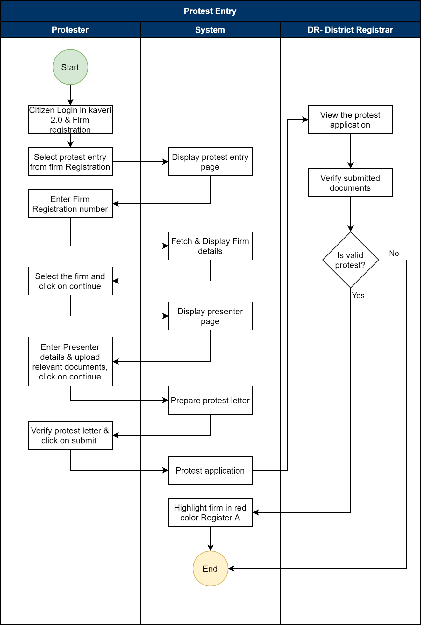

Functional Requirement Specifications
Stakeholder/ Interface | Role/ Responsibilities
Applicant (Protester) | - File the application for protest (Protest Letter)  - Online Data Entry  - Protest Letter  - Upload Relevant Documents
DR | - Verification of the Protest Letter.  - Verification of the documents Submitted  - Add Remarks (If Any)  - Accept/reject the protest.  - Authentication of protest entry.
System | - Retrieve the Firm Details upon Final registration number  - Collect the protester details.  - Prepare a protest letter.  - Highlight the firm with Red colour if the protest is valid.  - Updating in the Register of Firms and Its Index  - Accounting entry for each transaction in A-Register  - Generation of MIS Reports
Process Triggers | - Receiving application at DR Office
Process Description | Application Filing:  - Application to be filed in the Kaveri 2.0 Portal  - Select the Service required. The services provided are  - Registration of New Firm  - Amendment of firm  - Re-Constitution of Firm  - Dissolution of Firm  - Protest Entry  - Index Search  - Certified Copies  For Dissolution of Registered Firm, Applicant must enter the Following Details to fetch the details of the firm:  - The firm registration number (mandatory) for alphanumeric fields with only allowed special characters is “-” and the allowed characters are 20.  OR  - Firm Name (mandatory fields) alphanumeric fields with all the special characters allowed up to 250 characters.  - System displays the Firm name and principal place of business of the firm and the applicant clicks on ‘Proceed’ to proceed further.  - Applicant selects presenter (mandatory) radio buttons Partner and Objector.  - If the selection is partner, then the system should fetch and display the list of partners  - Else, in the case of the objector, objector details should be captured as below,  - Name of the Objector  - Salutation (dropdown) (Ex: Sri., Smt., M/S, Mr., Mrs., Ms., Kumari., Kumara) (mandatory field)  - First Name, Middle Name, Last Name (only First Name is mandatory field, Middle and Last Name are optional) 50 characters allowed.  - Relationship (dropdown) (Daughter of, Son of, Care of) (mandatory field)  - Relative Name (manually enter data) 250 characters. No special characters are allowed (mandatory field)  - Date of Birth (calendar) (Mandatory field)  - Age (in years) should be auto-calculated once DOB is entered, and age should be >=18.  - Gender (mandatory field) Radio Buttons – Male, Female, Transgender  - Occupation (optional field) 50 characters allowed  - Mobile Number (mandatory numeric field of 12 characters.  - Email ID (optional field) alphanumeric field with special characters with email ID format validation.  - Address –  House No./Building Name (250 characters, all the special characters are allowed), Street Address, State, District Taluka, Hobli/Ward, Village/City, Pin code (all are mandatory fields)  Note: Address can be anywhere in India  - Once the applicant selects the objector and clicks on the ‘Continue’ button, the system should display the summary.  - Applicant reviews the data, and he/she is provided with two options:  - Use the edit button at this stage to make changes (if necessary).  - View Protest Letter  - E-sign to complete the e-sign process.  - Close to come back to the summary page.  - Upon completing the E-sign process, the applicant should be redirected to the application to upload relevant documents (in PDF format, which allows up to 5MB).  - Protest Proof (mandatory)  - Address Proof of objector (Sale Deed / Rental Agreement / Tax Paid Receipt)  - ID Proof of the Objector (Driving License / PAN / Voter ID (EPIC Card) / Aadhar Card / Passport)  - Supporting Documents (if any – Optional)  - Applicant must view the fee table and click on the ‘Submit’ button.  - Application will be sent to DR for verification.  DR Self Verification:  - If the DR clicks the ‘Verify’ button to verify the protest application against a registered firm.  - The DR verifies the protest summary, documents uploaded by the protester, and other enclosures.  - Reject Protest – If DR finds that details are not valid and the objection or protest raised by the applicant is not valid, then DR clicks on the ‘Reject Protest’ button to reject the protest and notify the applicant to provide further documents in the presence of DR.  - Accept protest - If DR finds that the details are valid and the objection or protest raised by the applicant is valid, then DR clicks on the ‘Accept Protest’ button and highlights the firm in red in A-register.  Resolution:  - If the protest is valid, then make an entry in Register-A using red font/text.  - The system makes an entry in the register index.  Protest Documents:  - Protest Proof (mandatory).  - Proof of Identity for protester (Aadhar Card/PAN Card/Driving/License/Passport/EPIC Card (Voter ID)/Other)  - Proof of address for protester (Aadhar Card/PAN Card/Driving/License/Passport/EPIC Card (Voter ID)/Other)  - Supporting documents (if any) (optional)  - Supporting document 1.  - Supporting document 2.
Interfaces and purpose
  System | Information Received | Information Sent
  A Register | Protest details, protestor details
  Register of Firms and its Index | Highlight the firm name in red in case of a successful protest.  Makes and entry in index of firms.

5.6 Index Search
If any partner or any person interested knows the firm details then they’ll search the index of registered firms
Sl. No. | Action required | Actors | Statutory provisions
1 | Applicant searching the firm details | Applicant | As per rule 9(a) Karnataka Partnership (Registration of Firms) Rules 1954
2 | Details of firms | DRO | As per rule 9(a) Karnataka Partnership (Registration of Firms) Rules 1954

Process Flow
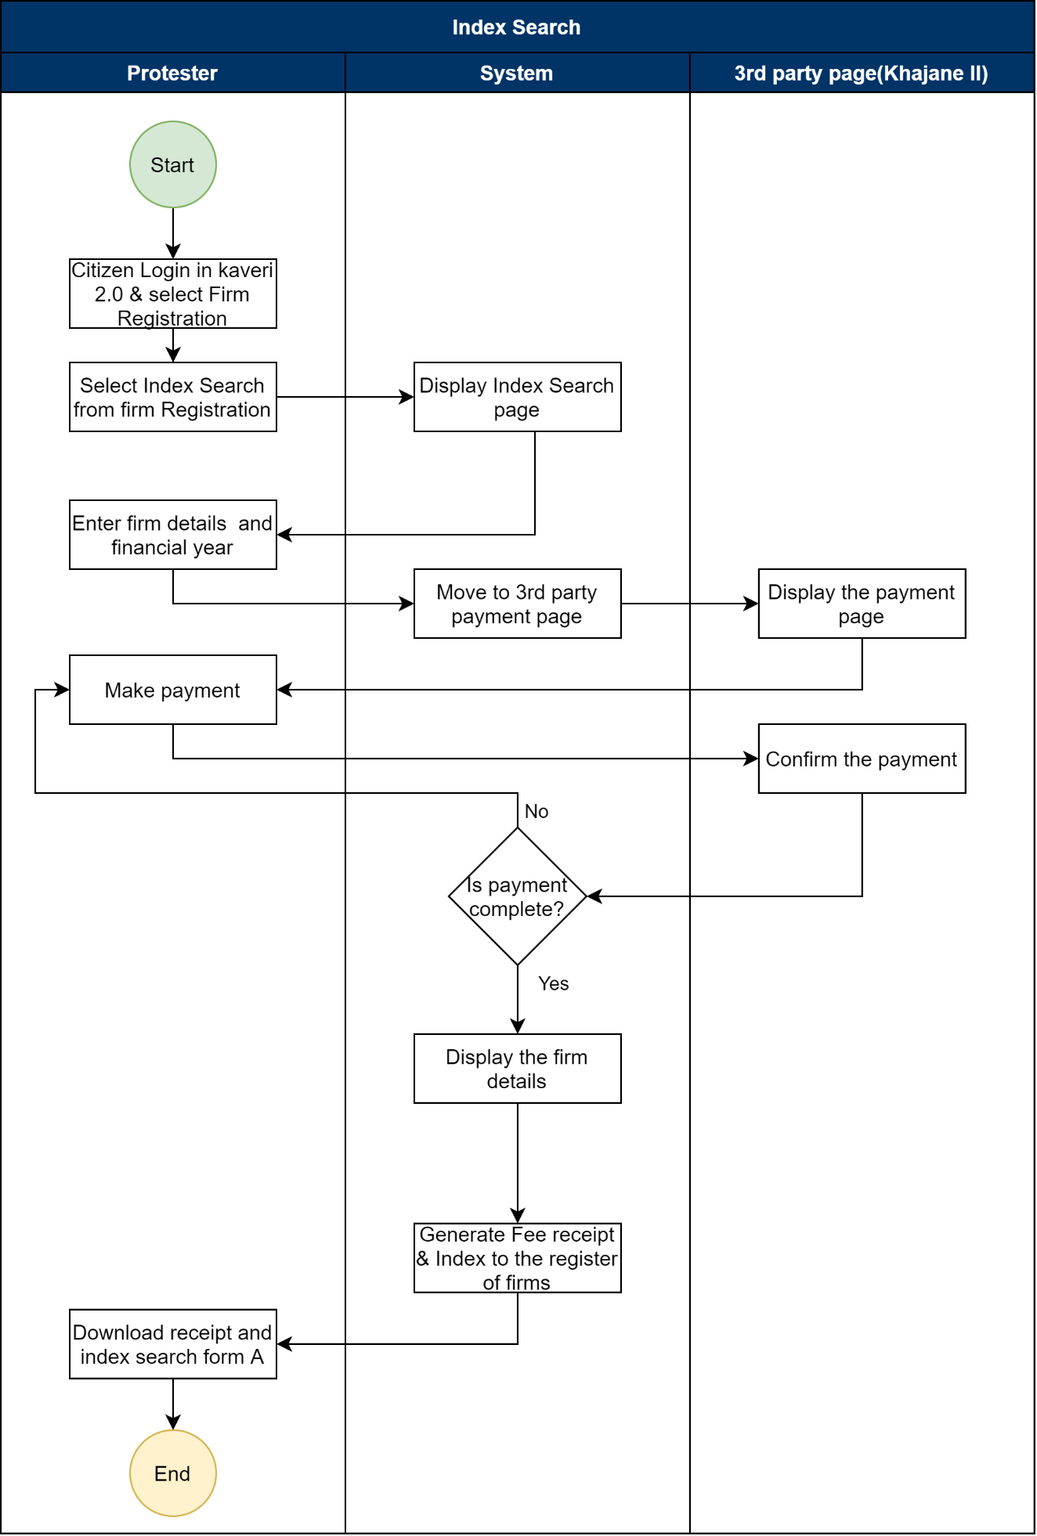
Figure 7: Process flow for Index search
Functional Requirement Specifications
Stakeholder/ Interface | Role/ Responsibilities
Applicant | - File the application for index search.  - Online Data Entry  - Payment of fees  - Collect Fee Receipt and Index for the Registers of the firm (Form B)
System | - Retrieve the Firm Details upon Final registration number  - Fetches the details of firms  - Print Acknowledgment and Fee Receipt  - Updating in the Register of Firms and Its Index  - Accounting entry for each transaction in A-Register  - Generation of MIS Reports
Process Triggers | - Making the payment and applying.
Process Description | Application Filing:  - Application to be filed in the Kaveri 2.0 Portal  - Select the Service required. The services provided are  - Registration of New Firm  - Amendment of firm  - Re-Constitution of Firm  - Dissolution of Firm  - Protest Entry  - Index Search  - Certified Copies  - Applicant enters the below details to search the firms,  - District  - Firm Name  - Registration number  - Period of search (Calendar) From date and To date.  The applicant clicks on the ‘Search’ button to proceed further,  - System fetches and displays firm details.  - Applicant verifies the details and clicks on ‘Proceed to payment’.  - Pay the prescribed fees.  - System fetches the details in Form B and Fee receipt.  - Citizens can download Form B and Fee Receipt.  Fee Calculation (System)  - The System shall calculate and display the fee for processing the application  - Fee is INR 1 for 1st year and then 50ps for every subsequent year.  - Applicant Shall View the Fee Details and click on ‘Make a payment’ to continue with payment else click on ‘Back’ to go back to the search page.  Payment:  - The system should show the calculated fee (freeze it and the applicant can make no changes at this stage) before the applicant makes the payment and then give the ‘Proceed to Payment’ option)  - The applicant shall make payment in the Khajane 2.0 portal (Total Payable Amount) online through the K2 portal by clicking on the ‘Proceed to Payment’ button  Accounting:  - System then updates the index of Firms and A-Register  - Details logged in the A-Register are as follows:  - Registration number  - Date of Registration  - Duration of firm  - Fee Collected  - Fee Receipt number  - Date of Stamping
Interfaces and purpose
  System | Information Received | Information Sent
  A Register | Fees Collected, Date of application, type of document requested | Fees Collected, Certified copy
  Register of Firms and its Index

5.7 Certified copy - CC
The Registrar shall, on application, furnish to any person, on payment of such fee as may be prescribed, a copy, certified under his hand, of any entry or portion thereof in the Register of Firms.
Sl. No. | Action required | Actors | Statutory provisions
1 | Applicant applied for certified copies | Applicant | Section 67 of Karnataka Partnership (Registration of Firms) Act 1932 and as per rule 17 Karnataka Partnership (Registration of Firms) Rules 1954
2 | Provide a List of forms requested | DRO | Section 67 of Karnataka Partnership (Registration of Firms) Act 1932 and as per rule 17 Karnataka Partnership (Registration of Firms) Rules 1954

Process Flow

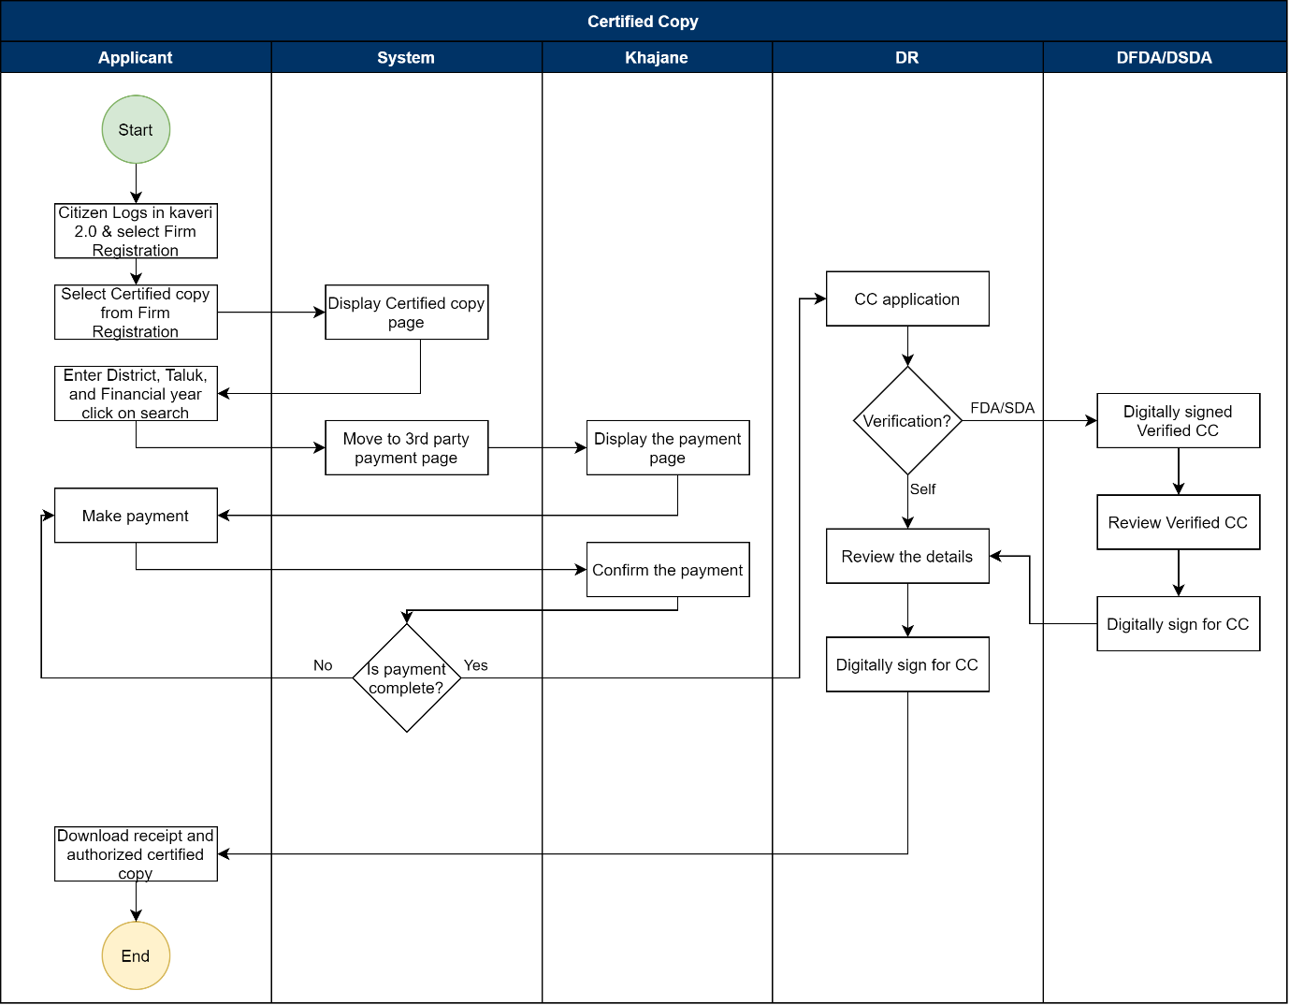
Figure 8: Process flow for Certified copy.

Functional Requirement Specifications
Stakeholder / Interface | Role/ Responsibilities
Applicant | - File the application for a Certified copy  - Online Data Entry  - Verify the entered details before submission.  - Payment of fees  - Collect Digitally Signed Certified copy and Fee Receipt
DR | - Verification of the digitally signed certified copy.  - Reject CC applications and notify the citizen  - Authentication of certified copy with digital sign
System | - Retrieve the Firm Details upon Final registration number/Name  - Calculation of Fee  - Generate Fee Receipt  - Updating in the Register of Firms and Its Index  - Accounting entry for each transaction in A-Register  - Generation of MIS Reports
Process Triggers | - Receiving application at DR Office
Process Description | Application for Certified copy:  - Application to be filed in the Kaveri 2.0 Portal  - Select the Service required. The services provided are  - Registration of New Firm  - Amendment of firm  - Re-Constitution of Firm  - Dissolution of Firm  - Protest Entry  - Index Search  - Certified Copies  To get a certified copy of a Registered Firm, the applicant must enter the following Details to fetch the details of the firm:  - District (dropdown with all district names in Karnataka)  - Select the type of Form from the dropdown (Form I, Form II, Form III, Form IV, Form V, Form VI, Firm Registration Certificate, Acknowledgement of Amendment and Form A)  - Financial year (drop down)  - The system fetches the Firm's requested documents and displays them.  - Applicant verifies the details and clicks on the ‘Proceed’ button.  - Applicant must choose a Presenter from the dropdown with the list of partners.  - Applicant views the application form and is provided with two options:  - Use the edit button at this stage to make changes (if necessary).  - View Summary (which displays CC application upon clicking)  - E-sign to complete the e-sign process.  - Close to come back to the summary page.  - Upon completing the E-sign process, the applicant should be redirected to the application to the payment page.  - Pay the prescribed fees and apply.  Fee Calculation (System)  - The System shall calculate and display the fee for processing the application  - Registration Fee = Rs.10 (fixed)  - Application Fee = Rs.1 (fixed)  - Total Payable Amount (in Rs.) = 11  - Applicant Shall View the Fee Details and Submit the Application  Verification by DFDA/DSDA:  - The DFDA/DSDA shall start the verification process by selecting the ‘Start Verification’ button  - The DFDA/DSDA Application Verification screen is split into two sides:  - LHS (Left-hand side of the page) – the Summary sheet containing all the details that the Applicant has entered (Fetched firm details, Date of Dissolution of Firm, fee details), a section to add his remarks, and a button to send it back to the DR  - RHS (Right-hand side of the page) – contains the E-Signed with firm details.  - If the details match the records, DFDA/DSDA generates a Certified document and authorises it by D-sign  - DFDA/DSDA sends it back to the DR with Remarks by clicking on ‘Send back to DR.’  Authorisation of CC:  - DR logs in and can see the application for CC in the Dashboard.  - The DR will click on ‘Verify’ to view the application.  - If details are valid, then click on ‘Authorize’ and digitally sign.  - The system sends the Payment Receipt (Form E) and digitally signed Certified copy to the applicant's login for download.  Accounting:  - System then updates the index of Firms and A-Register  - Details logged in the A-Register are as follows:  - Registration number  - Date of Registration  - Duration of firm  - Fee Collected  - Fee Receipt number  - Date of Stamping
Interfaces and purpose
  System | Information Received | Information Sent
  A Register | Fees Collected, Date of application, type of document requested | Fees Collected, Certified copy
  Register of Firms and its Index

Integration with other systems/modules

External integration
- This module has an integration with the external system Digi locker data centres for E-sign.
- Data migration from Kavari-1 to Kaveri-2.
- Integration with SAKALA

Assumptions and Dependencies

Assumptions:

Dependencies:
This feature depends on the Aadhaar database.

Limitations
Certified copies:
Registration Certificates (Form C) of firms registered in Kaveri 1 will be shown as is.
Providing All input forms (form 1 to form 6) and Form A for Kaveri 1 registered in firms is not possible.

Annexure – 1 – List of modules of Kaveri 2.0
Sl No | Module No | Main Module | Sub-Module
1 | 1.1 | Registration | Registration
2 | 1.2 | Registration | Appointment
3 | 1.3 | Registration | Integration module
4 | 1.4 | Registration | Stamp duty and Registration fee calculation
5 | 1.5 | Registration | Guideline value calculation
6 | 1.6 | Registration | Rule 17 (2) filing
7 | 1.7 | Registration | Rule 17 (3) filing
8 | 1.8 | Registration | Old pending release module
9 | 1.9 | Registration | Re-Registration module
10 | 1.1 | Registration | Will after Death
11 | 1.11 | Registration | Filing documents (FRUITS)
12 | 1.12 | Registration | Scanning
13 | 1.13 | Registration | Memo transmission and filing
14 | 1.14 | Registration | 68(2) correction
15 | 1.15 | Registration | Cross-reference Rule 123
16 | 1.16 | Registration | Integration exemption
17 | 1.17 | Registration | Court entry
18 | 1.18 | Registration | Liability
19 | 1.19 | Registration | Status tracking
20 | 1.2 | Registration | Investigation and Search
21 | 1.21 | Registration | Valuation Module (CVC)
22 | 2 | EC
23 | 3 | CC
24 | 4 | Verify Document
25 | 5 | Power of attorney Authentication Module
26 | 6 | Refund Module
27 | 7.1 | Marriage | Hindu Marriage
28 | 7.2 | Marriage | Special Marriage
29 | 7.3 | Marriage | Special Marriage in Other Forms
30 | 8 | Legacy Record digitisation
31 | 9 | Audit
32 | 10 | Accounts
33 | 11.1 | MIS | Statutory (44)
34 | 11.2 | MIS | Statistical (54)
35 | 11.3 | MIS | Integration (15)
36 | 11.4 | MIS | Computer related (4)
37 | 11.5 | MIS | Reconciliation (5)
38 | 11.6 | MIS | HR (5)
39 | 12.1 | DRO | Firm Registration
40 | 12.2 | DRO | Undervaluation
41 | 12.3 | DRO | Deposit of will
42 | 12.4 | DRO | Adjudication of documents
43 | 13 | IGRO | Appeal
44 | 14 | Master Data Management
45 | 15 | User Management
46 | 16 | Mobile application
47 | 17 | Training Module | Master Trainer, Training Plan

Annexure 2: Objectionable Names or Emblems
THE EMBLEMS AND NAMES (PREVENTION OF IMPROPER USE) ACT, 1950
ACT NO. 12 OF 1950
- United Nations Organization -UNO
- World Health Organization - WHO
- The Indian National Flag
- Government of India or of any State, or any other insignia or coat-of-arms used by any such Government or by a Department of any such Government
- The President, Governor, [Sadar-i-Riyasat] or Republic or Union of India
- Any name which may suggest or be calculated to suggest—
(i) the patronage of the Government of India or the Government of a State; or
(ii) connection with any local authority or any corporation or body constituted by the Government under any law for the time being in force
- United Nations Educational, Scientific and Cultural Organisation - UNESCO
- Rashtrapati, Rashtrapati Bhavan, Raj Bhavan
8A. Mahatma Gandhi, Shrimati Indira Gandhi, Chatrapati Shivaji Maharaj or the Prime Minister of India, Gandhi, Nehru, Shivaji
8B. Shri Lal Bahadur Shastri
- Ashoka Chakra, Shourya Chakra, Vir Chakra, Bharat Ratna, Gallantry Awards, Padmasri, Padma Bhushan, Padma Vibhushana, Jnanapith, Dhyanachand, Dadasaheb Phalke, Tensing Norgay or any other name of the awards given by the Government
- International Civil Aviation Organisation
- Interpol - International Criminal Police Organisation
- World Meteorological Organisation - WMO
- Tuberculosis Association of India
- International Atomic Energy Agency
- The names “Ashoka Chakra” or “Dharma Chakra”
- The name of the Parliament or the Legislature of any State, or the Supreme Court, or the High Court of any State, or the Central Secretariat, or the Secretariat of any State Government or any other Government Office
- Rama Krishna Math and Mission
- Sri Sarda Math and Ramakrishna Sarda Mission
- The Bharat Scouts and Guides
- International Olympic Committee
- National Youth Emblem
- Auroville
- Sri Sathya Sai Central Trust
- Sri Sathya Sai, Sarve Bhavantu Sukhinah
- NHRC/nhrc: National Human Rights Commission
- FIFA: Federation Internationale de Football Association

Annexure 3: Checklist under DRO Login
Below mentioned points are to be provided with a check box to tick whether the documents were received or not:
Support Document Description:
- Form I: Registration form for the incorporation of a Partnership Firm
- Memorandum/Rules/ Member Information
- ID Proof
- Address Proof
Below mentioned questions below are to be provided with a check box to tick the Yes or No options and Remarks Column to enter DR remarks.
I. Firm Details
- Whether the application is presented with proper authorisation?
- Whether all corrections in the application form are attested?
II. Name & Address
- Whether Name of the Firm do not contain prohibited words?
- Whether Name of the Firm is as per Law?
- Whether the Address of the Firm is as per Partnership Deed/
- Whether the Principal Place of Business is in the jurisdiction of the Registrar?
III. Partner Details
- Whether Name, Age and Address are as per the Partnership Deed?
- Whether the date of joining is as per the Partnership Deed?
- Whether the duration of the firm is as per the Partnership Deed?
- Whether the copy of the deed of partnership is submitted for the verification?
- Whether Date of Execution is mentioned in the partnership deed?
- Whether Name and Address of all the members are forthcoming in the partnership deed?
- Whether Stamp Duty is paid as per the Stamp Act?

Annexure 4: Input and Output Forms
Sl. No. | Module | Description | Input | Output
1 | New Firm | New Firm Registration | Form I | Form C
2 | Amendment | Change in name of firm or principal place of business | Form II | Form D
3 | Amendment | Intimation of change in place of business other than Principal Place of Business | Form III | Form D
4 | Amendment | Intimation of alteration in the name or permanent address of partners | Form IV | Form D
5 | Amendment | Notice of election by a person admitted to the benefits of partnership attaining majority | Form VI | Form D
6 | Reconstitution / Dissolution of firm | notice of changes in the constitution of the firm or of the dissolution of the firm | Form V | Form D
7 | Protest entry | Provision made in the application (Rule 7) | NA | NA
8 | Index Search | Provision Made under application (Rule 9a) | NA | Form B
9 | Certified Copy | All the input and output forms of Firm Registration/Amendment/Reconstitution or Dissolution and Form A | NA | Filled Form I to VI, Form A, Form C and Form D

Annexure 5: Clarificatory questions and Answer from Department,

Feedback provided by Department, dated: 19-07-2024

New Firm Registration:
- During a New Firm registration date of the constitution and the date of partners joining the firm should be the same or different.
Answer: Same
- What details should be captured at the interfaces and purpose section?
Answer: As per FORM 1 all details

Amendments:
- Do we need to capture the date of amendment?
Answer: Yes
- In amendment 1 can we change the nature of business.
Answer: Yes
- Is there any time limit to notify the amendments to DR?
Answer: 15 days, as per rule 4(2) of Karnataka Partnership (Registration of FIRMS) rules, 1954.
- If the amendment is notified after the prescribed time what is the penalty amount?
Answer: No provision for penalty
- For amendments 2,3 and 4 do we need to take the sign of all partners or only the relevant partner's sign is acceptable?
Answer: All Partners
As per the below image we can see that there is an attestation, is it the witness attestation?
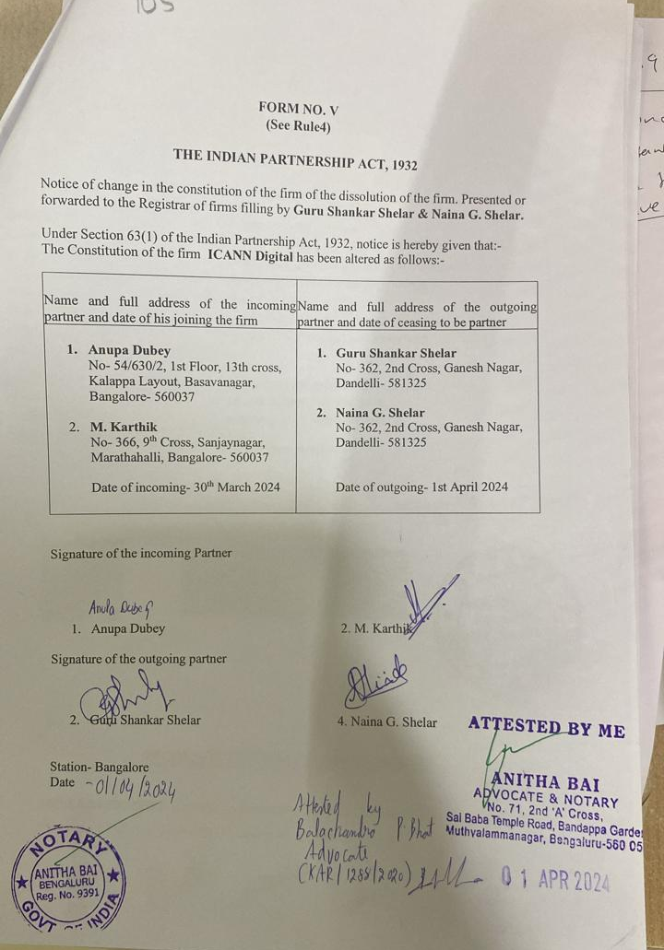
- Do we need to collect witness details and signature to all the amendments?
Answer: Yes
- For amendment 4 do we need to take the date of election to become a partner once he/she attains majority?
Answer: Yes

Reconstitution:
- What is the document for to be collected by reconstitution of firm?
Answer: 1. FORM V
2. Reconstitution deed
3. Self-attested ID and Address Proof of the Incoming parties
4. IF the Retiring partner has not contributed any immovable property to the firm and has not taken away any immovable property from the firm, a notarised affidavit on rs. 100/- E Stamp paper swearing that he has not contributed any immovable property to the firm and not taking away any immovable property from the firm.

Dissolutions
- While dissolving a firm what happens to other existing partners? Do they exit first and then dissolution happens or both reconstitution and dissolution will take place together?
Answer: Dissolution takes place at a time.

Certified copy:
- Do we have any application format to apply for CC?
Answer: No
- For which documents can an applicant apply for CC on the firm registration module?
As per the below image, we have observed only form A and along with this document, which are the other documents applicants can get as certified copies
Answer: Form 1 to 6, From A, C, D
- What is the fee for a CC application? I need clarification on the queries below:
  - As per act it says INR 1 for Form C (registration certificate)
  - For any other document 50 ps for each 100 words and part thereof.
  - Do we need to collect any application fee?
Answer: FORM A, C and D
- For what duration an applicant can apply for CC? is it for a financial year or between a particular period?
Answer: A particular period
- The CC should be verified and Digitally signed by DR or it should be verified by any DFDA/DSDA and digitally signed by both?
Answer: Both
- Do we need to get the E-sign done by an applicant to apply for CC?
Answer: Yes

Index Search:
- What details should be displayed in these fields of Form B: File name and Volume number, 1st page entry,
Answer: Registration number, FIRM Name and address, date of registration, duration and partners details.
- Please share a copy of the index of the firm (form B).
Answer: 1. Firm Name
2. Serial number borne on register.
3. Volume number of register
4. First page of entry in the volume
5. Remarks
6. Signatures/of Registrar
- Is the index to the firm to be updated regularly for all the transactions (like Form A or A-register)
Answer: Yes

Protest Entry:
- Need clarification on protest entry flow, what happens if protest is accepted and what happens if protest is rejected?
Answer: As per rule 7 of Karnataka Partnership (Registration of FIRMS) Rules, 1954, where any partner or other person interested makes a protest in writing, disputing any entry made in the register of firms, the registrar shall record such protest and make a reference thereto in red ink in the remarks column against the disputed entry.
- Once the protest is accepted or rejected by the DR, does the protester get any intimation?
Answer No
- For protest entry, what are the fees to be collected?
Answer: No fee.
- What details should system capture and make note in Register A, when an applicant applies for Index search, protest entry and certified copy?
Answer: Register Number, FIRM Name and address, date of registration, Duration and Partner details

SAKALA Integration:
- Do we need to integrate with SAKALA and send intimation to applicants via SMS?
Answer: Yes
- If yes then please share the SMS templets if you have.
Answer:
Submission of Application

Your FIRM application (FORM I /II/III/IV/V/ VI ) is submitted successfully to DRO Office name with application number xxx. From : Department of stamps and registration.

Send back with remarks:
Your FIRM application xxx (FORM I /II/III/IV/V/ VI ) submitted to DRO Office name has sent back with remarks. From : Department of stamps and registration.

Payment:

Your FIRM application xxx (FORM I /II/III/IV/V/ VI ) submitted to DRO Office name has been verified and sent for payment. From : Department of stamps and registration.

Submission Template post payment:
Your FIRM application xxx (FORM I /II/III/IV/V/ VI ) is submitted to DRO Office name with Sakala number IGxxxx it will be processed in x working days. From : Department of stamps and registration.

Post Dsign message:

Your FIRM application xxx (FORM I /II/III/IV/V/ VI ) is been registered successfully with number xxx at DRO Office name. Please login to your account to download the certificate. From : Department of stamps and registration.

Feedback provided by the Department, dated: 26-07-2024
FORM 1
1. There is no provision for print receipt in Department login
2. Identification of witness, identifier can identify one or more partners. If single witness identify both witness then no need of additional witnesses.
3. Form 1, E-sign of witness should be captured in all the place holders asking for E-sign.

FORM 2,3,4,5,6
1. Change in the name of the firm or in the location of the principal place of business for FORM 2
2. Do not provide option to change Nature of Business for FORM 2.
3. Partners and agent screen is not been displayed for FORM 2.
4. Witness screens are not required for FORM 3,4,5,6
5. Esign is enough for any one of partner/agent for FORM 3,4
6. For FORM 5 only esign should be captured for incoming and outgoing partner/agent,
7. If FORM 5 is for disolution then signature for one of partner/agent in existing partners is sufficient.
8. For FORM 6 esign should be captured for partner who has atained as major or by its agent. Please refer section 30(5) logic is been validated.
9. Protest entry - Post successfull acceptence of protest entry should be captured in remarks column in report of "Index to the register of firms".
10. Index and Certified copy seach- taluk is not required.

Fee required details
FORM 1
Registration fee 100
Filing fee 3

FORM 2
Registration fee 50
Filing fee 1

FORM 3
Registration fee 25
Filing fee 1

FORM 4
Registration fee 25
Filing fee 1

FORM 5
Registration fee 25
Filing fee 1

FORM 6
Registration fee 25
Filing fee 1

NOTE:
1. No offline flow if E-Sign is getting failed from citizen in FRS.
2. No workflow to handle Kaveri 1 FIRM registered documents for Amendments, Dissolution and Reconstitution

Feedback provided by the Department, dated 21-08-2024
- What is the process flow for applicants who are not willing to do an E-sign/ In case of E-Sign Failure cases (offline flow)?
Ans: Two options should be given to Sign one: Sign online(E-sign) and Sign Offline; applications with E-sign will be submitted to DR after successful payment for registration, and applications with manual signatures, duly signed applications should be submitted to the District Registrar Office for registration.
- Do we need to differentiate between the online and offline modes of input and output documents?
Ans: There should not be any differentiation in either flow.
- Recommendations/Suggestions from the department
Mandatory Fields | Good to have features
We need to provide an option to view the application form in the DR/DFDA/DSDA login for verification. | A view widget in RHS is to be provided in the DR/DFDA/DSDA login to verify the details in the application form with uploaded documents.
Once the payment is done a receipt should be made available in all the logins. | A QR code will be provided in the certificate to scan and download the certificate.
Label changes:
- ‘Can proceed to payment’ button label to be changed to ‘Send for payment’
- ‘Correction’ button label to be changed to ‘Send for correction’
- ‘Firm registration penalty’ label to be changed to ‘Delayed filing penalty.’
 | Check for feasibility to validate the Mobile number.

Annexure 6: Input Forms

Application of new firm Registration Form- I

Amendment -I: Form II
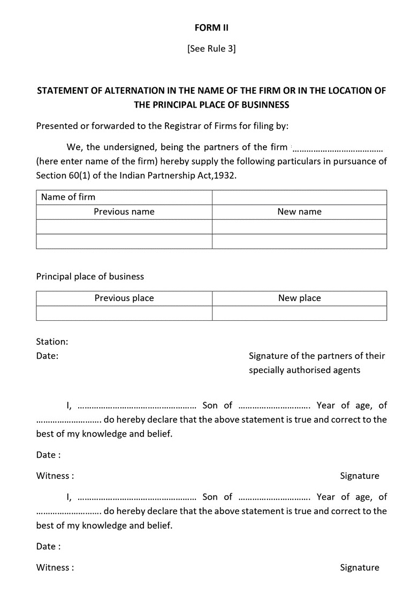

Amendment -II: Form III
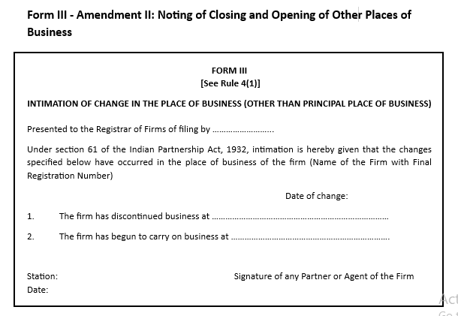

Amendment -III: Form IV

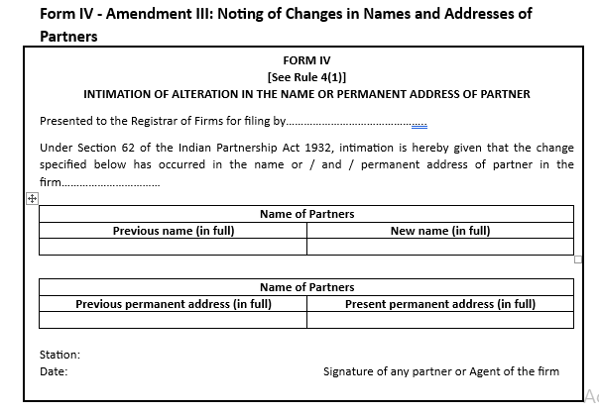

Amendment -IV: Form VI
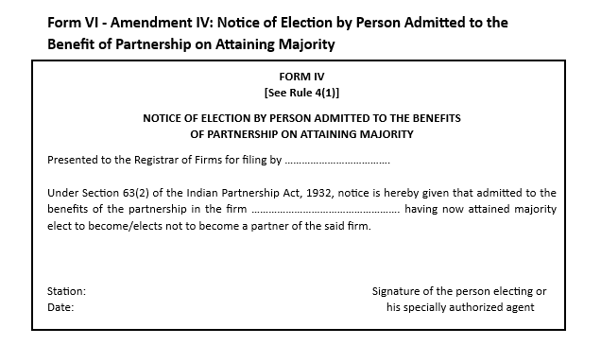

Re-Constitution: Form V
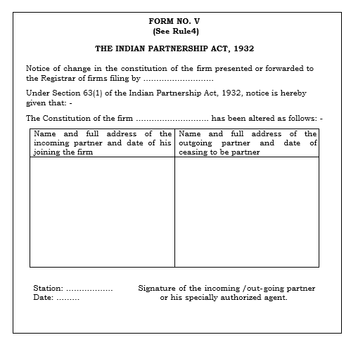

Dissolution: Form V

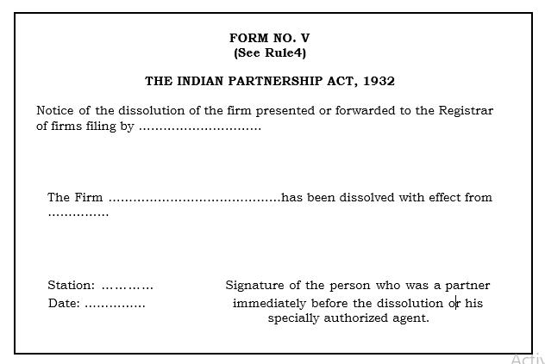

Annexure 7: Output forms

Form B Index to the Register of Firms
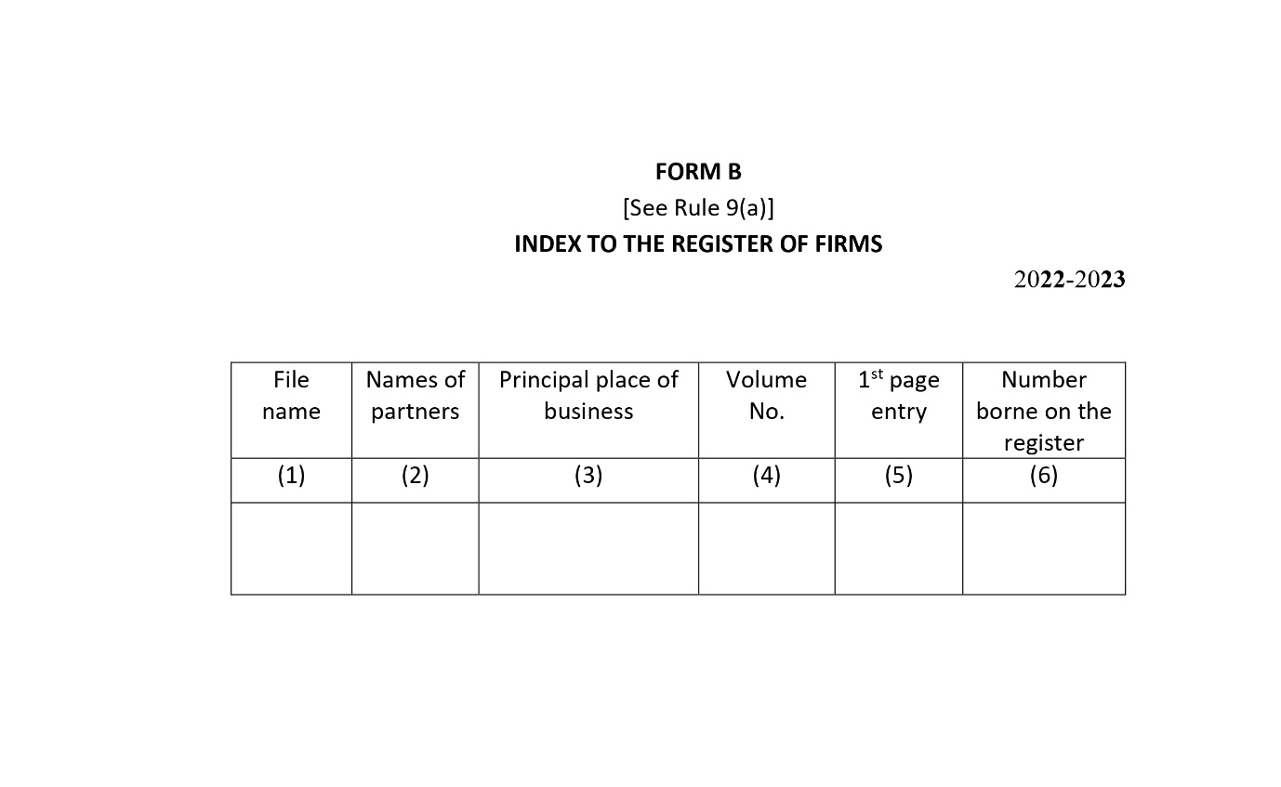

Form D Memorandum Acknowledging Receipts of Documents
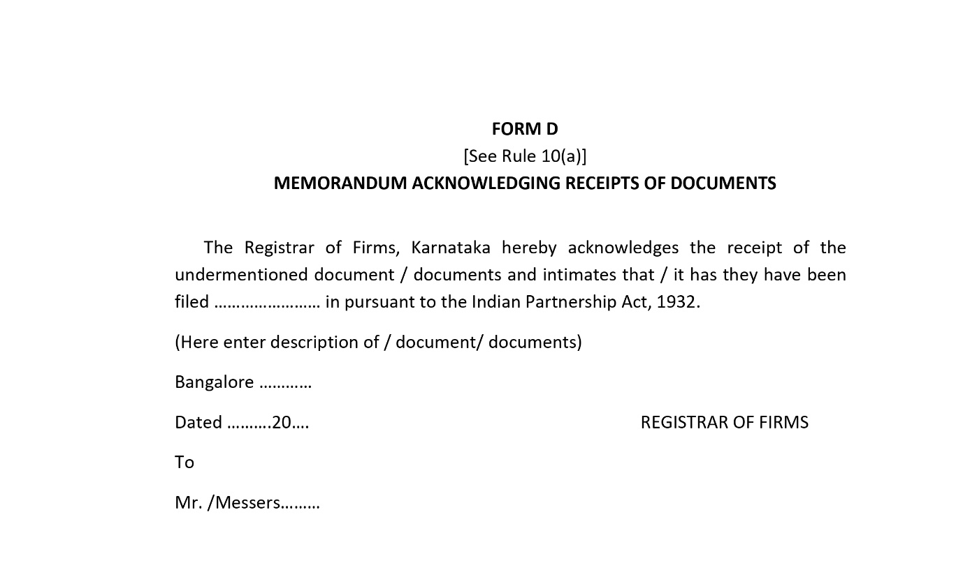

Form A Register of Firms
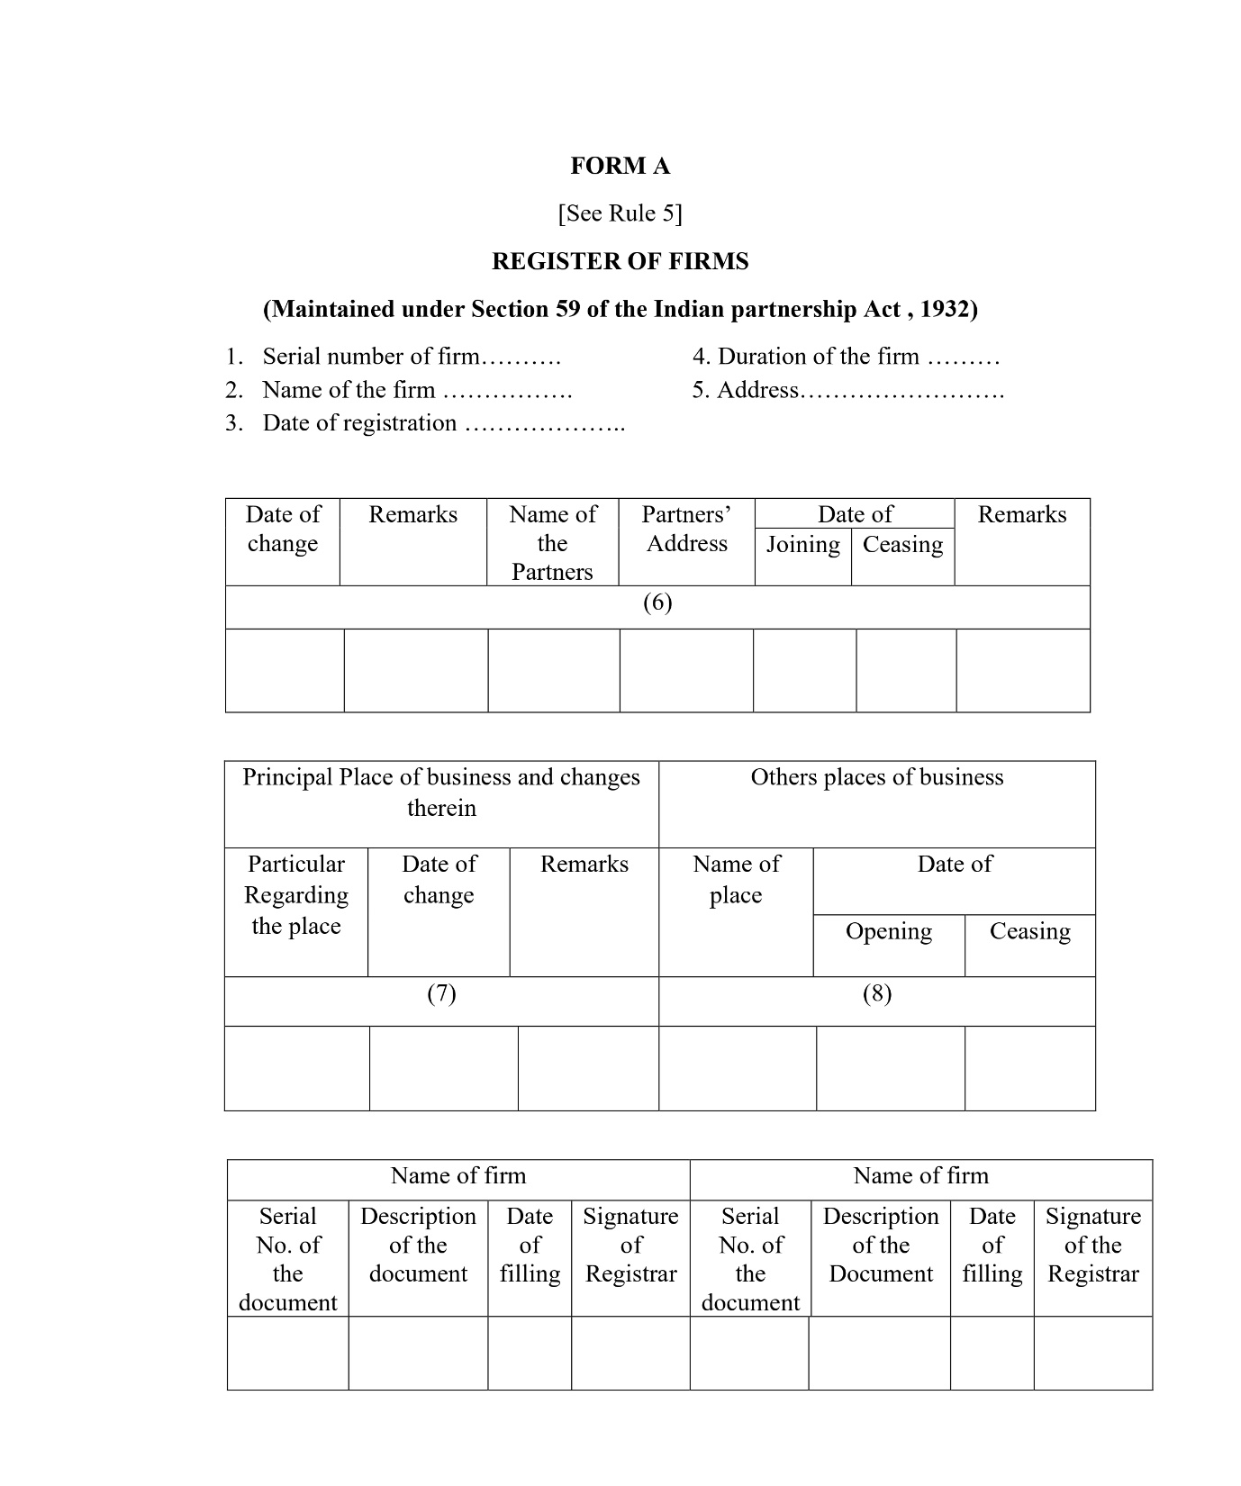

Form C Acknowledgement of Registration of Firms
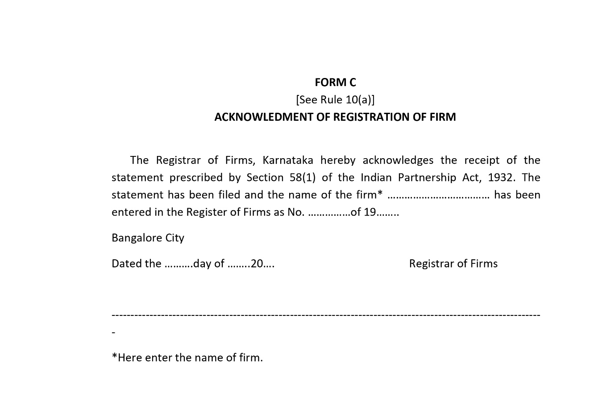

Form E Receipt of Fees
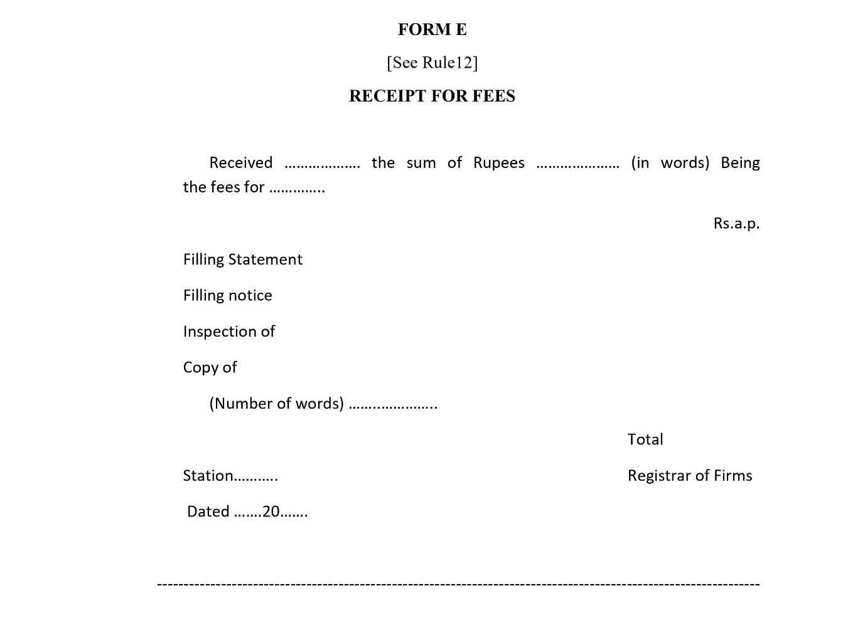

Annexure 8: Services to be provided for firms registered in Kaveri 1
The below table explains the type of data and nature of data available.
Service | Comment | Name of the firm | Address of the firm | Partner Name | Partner Address | Branch details | Result
New Firm | Name matching with existing firm master | Available | Not required | Not required | Not required | Not required
Amendment-1 | Name / Address of the principal place of business | Available | Available | Available | Available | Not required | Can be Done
Amendment-2 | Addition/Deletion of other place of business | Available | Available | Available | Available | Not available | It is not possible to remove branches as the details are not available.
Amendment-3 | Change the name/ permanent address of the partner | Available | Available | Available | Available | Not required | Can be Done
Amendment-4 | Election of minor partner after becoming major | Available | Available | Available | Available | Not required | Can be Done
Reconstitution | Name and address of incoming or outgoing partners | Available | Available | Available | Available | Not required | Can be Done
Dissolution |  | Available | Available | Available | Available | Not required | Can be Done
CC: form 1 to form 6 | All the application forms |  |  |  |  |  | It’s not possible, as data is not available.
CC: Form A | Details extract copy |  |  |  |  |  | It’s not possible, as data is not available.
CC: Form C | Firm Registration Certificate |  |  |  |  |  | It can be provided.
CC: Form D | Acknowledgement |  |  |  |  |  | It’s not possible, as data is not available.

After analysing the data, Kaveri 2 will handle the below mentioned service for firms registered in Kaveri 1 with limitations.
- Amendment 1:
  - Name of the firm can be amended.
  - Address of the firm: Existing firm address will be fetched and displayed in the 1st cell of Address section, applicant has to enter all the subfields in address field.
  - And typical flow continues.
- Amendment 2:
  - Address of the firm: Existing firm address will be fetched and displayed in the 1st cell of Address section, applicant has to enter all the subfields in address field.
  - As we’ve not seen any details of other places of business in the data shared with us hence applicant will be show addition of new place of business.
  - And typical flow continues
- Amendment 3:
  - Name of the Partners can be amended.
  - Address of the Partners: Existing firm address will be fetched and displayed in the 1st cell of Address section, applicant has to enter all the subfields in address field.
  - And typical flow continues.
- Amendment 4:
  - Recording of withdrawal of a minor: When a minor who has been admitted to the benefits of partnership in a firm attains majority and elects to become or not to become a partner.
  - Record the choice: Record the choice of partner.
  - And typical flow continues.

As per Indian Partnership Act 192, section 4 minimum 2 partners are required but there is no mention of maximum number of partners. The Central Government has prescribed maximum number of partners in a firm to be 50 vide Rule 10 of the Companies (Miscellaneous) Rules, 2014.Thus, in effect, a partnership firm cannot have more than 50 members
As per Indian Partnership Act, 1932 and rule 10 of misc. act companies act.
As per section 30(5), Indian Partnership Act 1932.
As per schedule I of section 71 (1) of Indian partnership Act 1932.
As per section 69A of Indian Partnership Act 1932
A DR can be notified about the amendments within 15 days, as per rule 4(2) of Karnataka Partnership (Registration of FIRMS) rules, 1954. And maximum of 90 days to avoid the penalty.
A DR can be notified about the amendments within 15 days, as per rule 4(2) of Karnataka Partnership (Registration of FIRMS) rules, 1954. And maximum of 90 days to avoid the penalty.
A DR can be notified about the amendments within 15 days, as per rule 4(2) of Karnataka Partnership (Registration of FIRMS) rules, 1954. And maximum of 90 days to avoid the penalty.
As per rule 13 of The Karnataka Partnership (Registration of Firms) Rules, 1954
As per rule 14 of Karnataka Partnership (Registration of Firms) Rules, 1954
Feedback provided by the Department, dated 17-07-2026 Requirement 1- Reconstitution of firm for K1 fetched registered Firm - On the Reconstitution page: - When the data from the K1 registered Firm details is fetched, since the data in the KAVERI 2.0 application is not saved. System redirects to Data correction to enter the details and save the data in the KAVERI 2.0 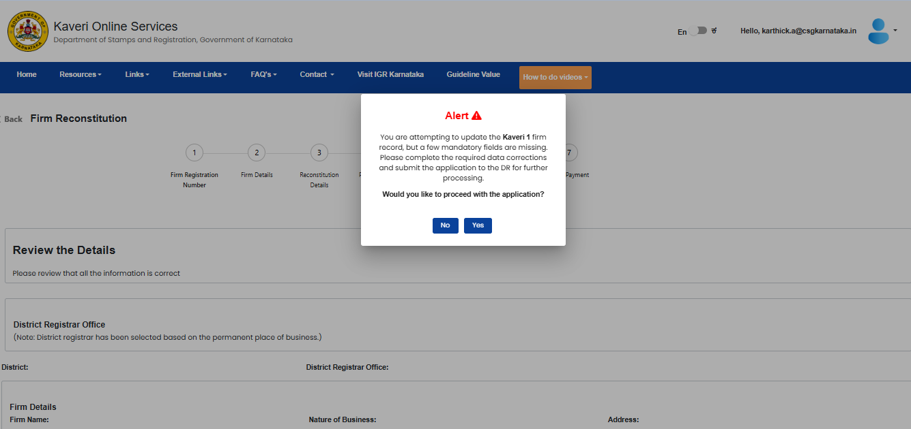 - Click on ‘Yes’ to continue. - In the Data Correction page, completely disable the Partnership Period field - Provide an option to manually enter the partnership duration (e.g., 5 years, 20 years, etc.). - The Number of Years field should be optional and should not be a mandatory field. 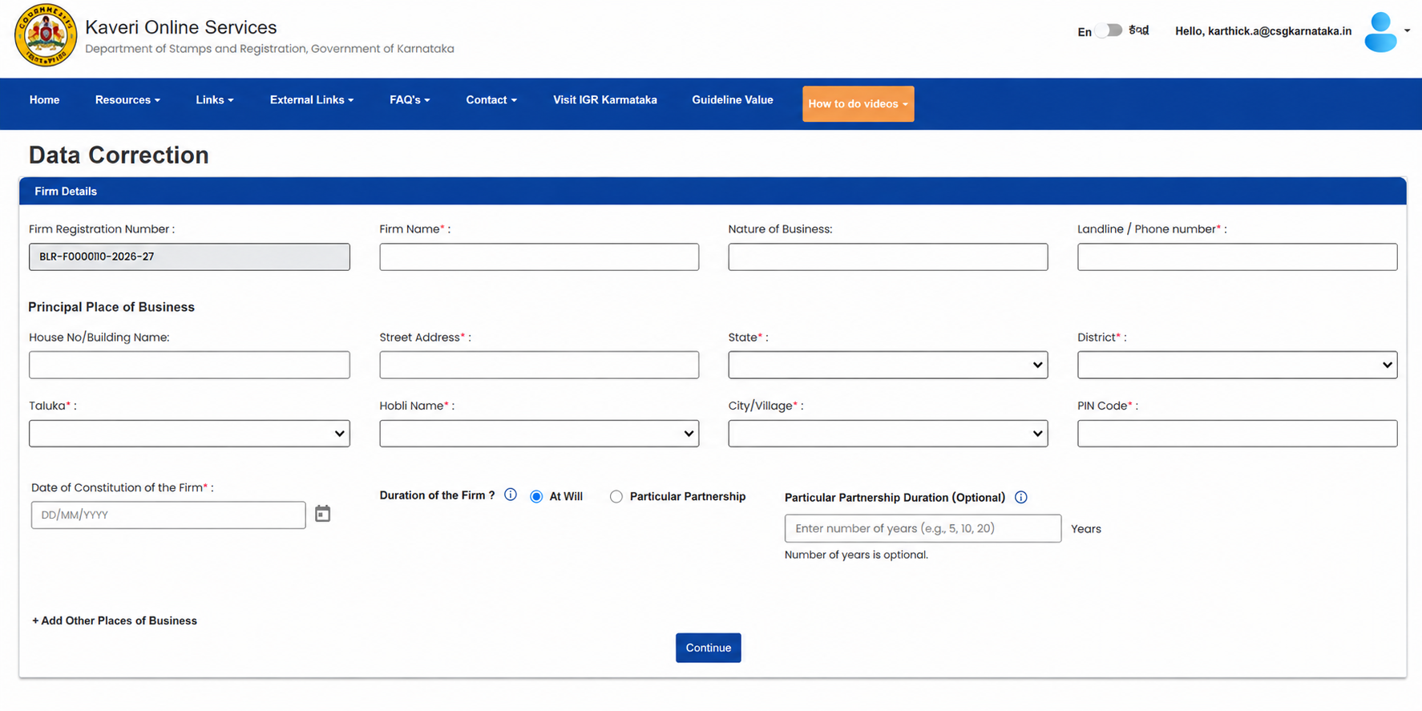 - The entered years will be saved in KAVERI 2.0 and continued with the existing with the reconstitution process flow. Requirement 2- Reconstitution of Firm for an outgoing partner in case of death - In the Reconstitution details page, upon selection of a partner from the partner list display a question; Select a reason of outgoing of a partner along with the radio button (mandatory) mentioning ‘Normal’ or ‘Death’; - If selected ‘Death’ add a field to upload the death certificate in the upload documents page. - If selected ‘Normal’, existing flow will be continued. - Select a reason and click on ‘Save partner’ to save the details of selected partner and click on the ‘Save and continue’ to proceed further. - In the Review summary page while doing an E-Sign, if the Outgoing partner is dead, the outgoing partner name should not be displayed in the list. - In the ‘Upload documents’ page in case of the death of a partner, the system should provide an option to upload the Death Certificate(mandatory) and allow the user to proceed with the reconstitution process. 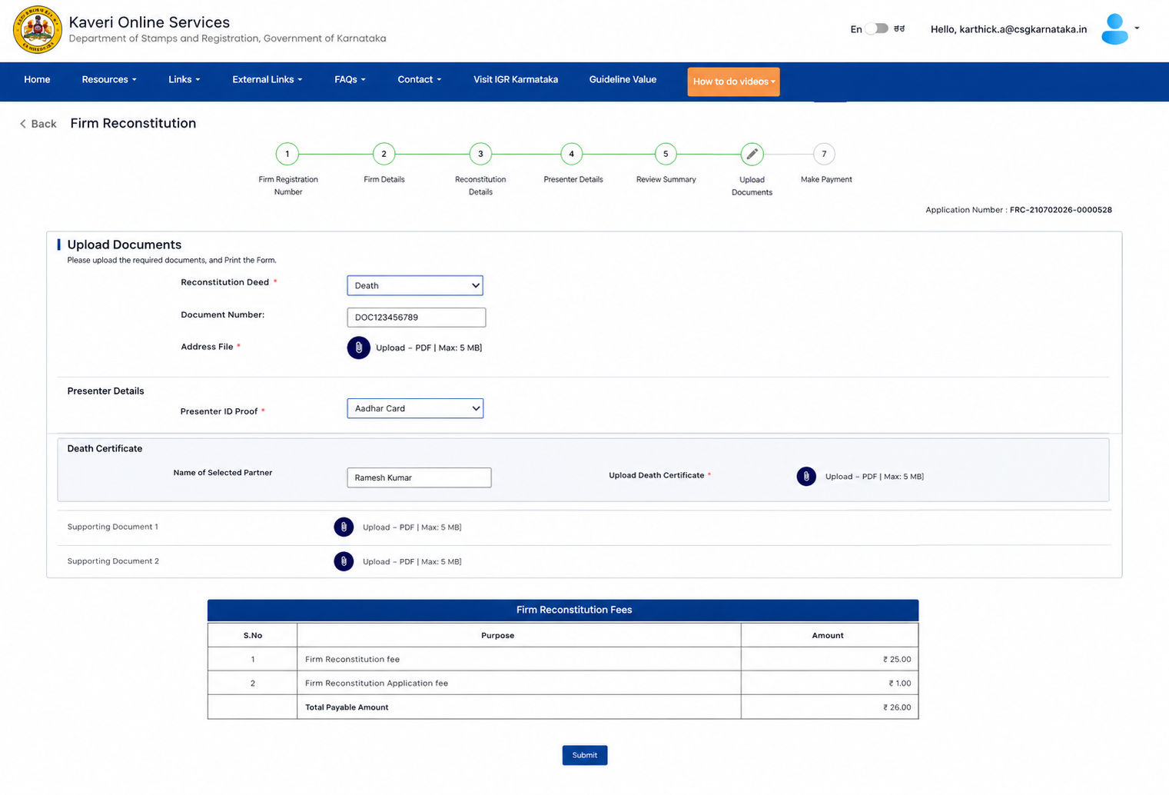 Note: Keep a provision to capture the Reason for Outgoing along with the supporting document upload option. This ensures the design is future-ready and can accommodate additional reasons for partner exit beyond death without requiring further UI changes. Feedback provided by the Department, dated 28-07-2026 Requirement 1- Add an outgoing partner details in the E-Sign page and Input form - In the reconstitution page, once the party details are saved and continued with the process. - In the E-sign page add note saying ‘Outgoing partner: outgoing partner name’. If the outgoing partner is dead, do not allow to E-sign. - In the Input form page, add the mention ‘outgoing partner: outgoing partner name’ details.

